THANK YOU! & Farewell to Cindie
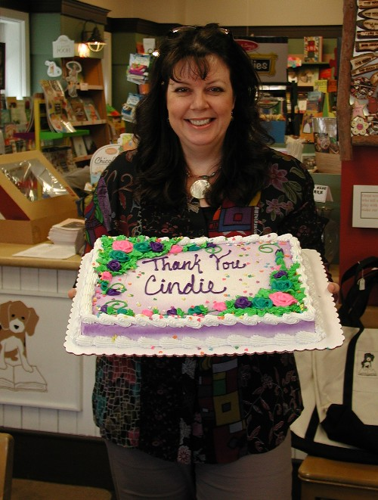
If you’ve been into Beagle Books, then you know Cindie and what an important part of Beagle Books she has been. Beagle’s former owner, Jill, hired Cindie nearly 10 years ago. We were blessed to have Cindie stay on board with us for 3-1/2 years after ownership changed hands. As many of you know, Cindie has steadily been working to build her own small business. We held a party for Cindie on her last day of work at Beagle. Thank you, thank you, THANK YOU Cindie for all you have done!!
To those of you interested in Cindie’s work, check out her website!:
http://awakenpastlives.com/
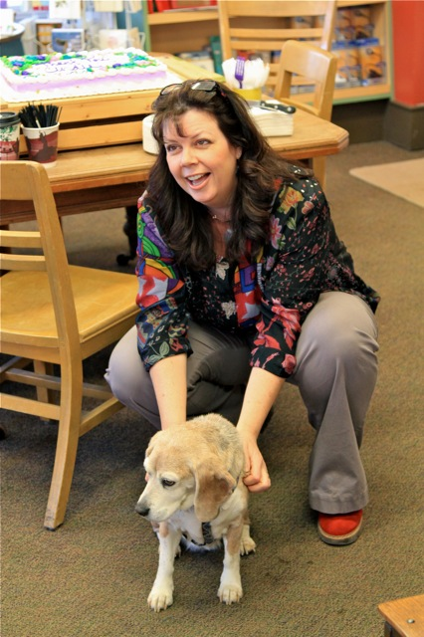Even Kallie, the original beagle, came to Cindie’s party to wish her well! (And beg a treat or two…)

ANN PATCHETT!
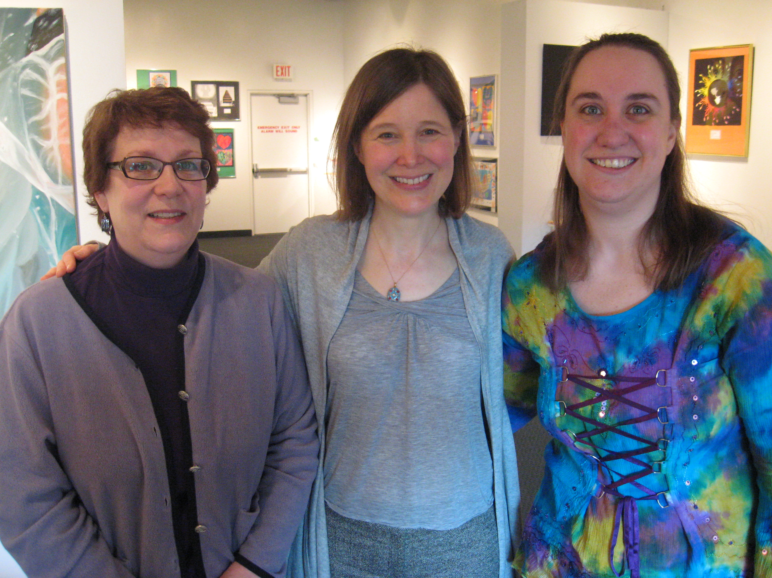
Look!! It’s Sally and Jen with ANN PATCHETT! The author of The Magician’s Assistant, Bel Canto and others! Patchett recently gave a talk as part of the Library Foundation of Hennepin County’s Pen Pals Author Lecture series. Sally and Jen attended and then afterwards got the chance to chat with the author! Teaser…. Patchett has a new book coming out in June called State of Wonder and it is REALLY good! We’ll tell you more in June when the book is released! (But feel free to pre-order now if you like ☺)
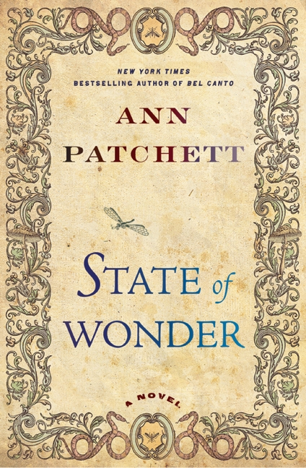

Sister Wolf Books
2011 opening date is………. MAY 5TH!
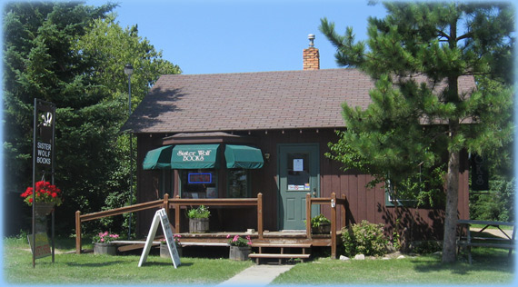

Midwest Connections Picks  April Picks:

The Bird Sisters by Rebecca Rasmussen $24
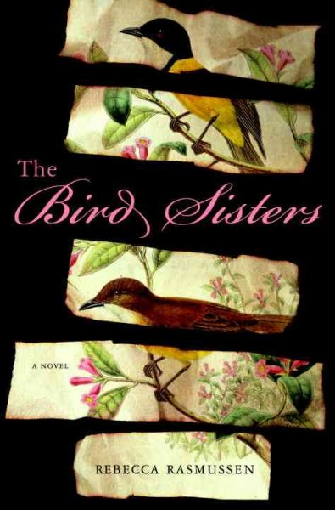 *One of Jen’s picks from this year’s Night-In event!

When a bird flies into a window in Spring Green, Wisconsin, sisters Milly and Twiss get a visit. Twiss listens to the birds' heartbeats, assessing what she can fix and what she can't, while Milly listens to the heartaches of the people who've brought them. These spinster sisters have spent their lives nursing people and birds back to health. But back in the summer of 1947, Milly and Twiss knew nothing about trying to mend what had been accidentally broken. Milly was known as a great beauty with emerald eyes and Twiss was a brazen wild child who never wore a dress or did what she was told. That was the summer their golf pro father got into an accident that cost him both his swing and his charm, and their mother, the daughter of a wealthy jeweler, finally admitted their hardscrabble lives wouldn't change. It was the summer their priest, Father Rice, announced that God didn't exist and ran off to Mexico, and a boy named Asa finally caught Milly's eye. And, most unforgettably, it was the summer their cousin Bett came down from a town called Deadwater and changed the course of their lives forever.

The Wilder Life: My Adventures in the Lost World of Little House on the Prairie by Wendy McClure $25.95
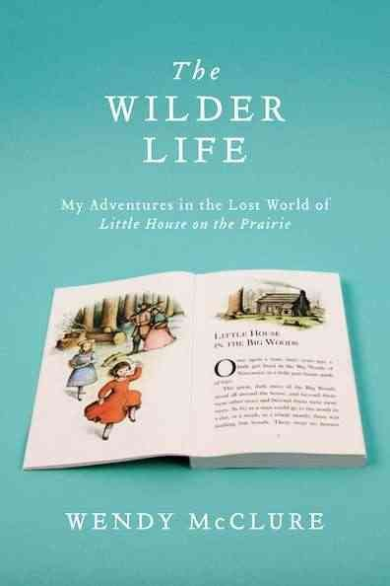
The Wilder Life is a spirited tribute to the series of books that have inspired generations of American women. Wendy McClure, who works as a children’s books editor at Albert Whitman & Company, traces the pioneer journey of the Ingalls family — looking for the Big Woods among the medium trees in Wisconsin, wading in Plum Creek, and enduring a prairie hailstorm in South Dakota. While hand-grinding wheat to make bread and churning her own butter, she truly immerses herself in all things Little House — and finds that the things you once loved stay with you wherever you go. Written partly in response to her mother’s death, Wendy McClure shows her readers where home is.

Bent Road by Lori Roy $25.95
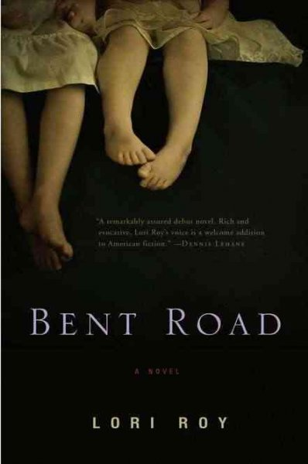
For twenty years, Celia Scott has watched her husband, Arthur, hide from the secrets surrounding his sister Eve's death. As a young man, Arthur fled his small Kansas hometown, moved to Detroit, married Celia, and never looked back. But when the 1967 riots frighten him even more than his past, he convinces Celia

to pack up their family and return to the road he grew up on, Bent Road, and that same small town where Eve mysteriously died.
Mothers & Daughters by Rae Meadows $25 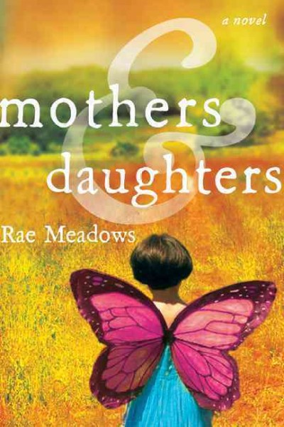
Set in Madison, Wisconsin, Mothers and Daughters by Rae Meadows is about three generations of women — Sam, Iris, and Violet — their stories intertwined to span the twentieth century. Their tale ranges from the measured calm of the contemporary Midwest to the seedy underbelly of early-twentieth-century New York City and the infamous orphan trains that shuttled unwanted infants out of the city. Inspired by her own journey into motherhood, Rae Meadows explores the feeling of being “knocked off balance by motherhood.” She shows readers how to recognize themselves and their loved ones — no matter how much anyone changes over time. Mothers and Daughters is rich and luminous novel about three generations of women in one family: the love they share, the dreams they refuse to surrender, and the secrets they hold.
Staff Picks Linda:
61 Hours by Lee Child $9.99 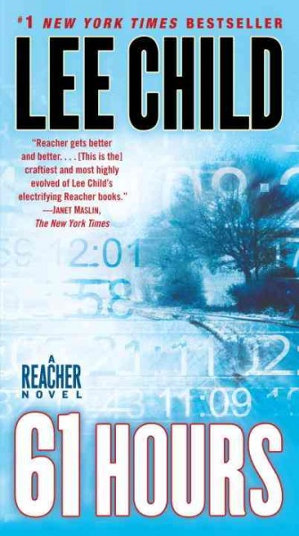 Linda says: Jack Reacher gets unexpectedly plopped into a South Dakota blizzard of cold and harrowing adventure.

Two Kisses for Maddy: A Memoir of Loss & Love by Matt Logelin $24.99
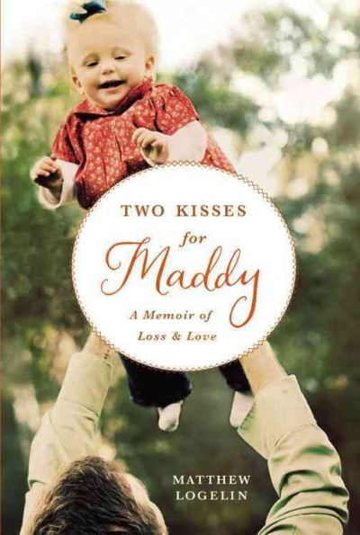 Linda says: When Matt's wife dies of a pulmonary embolism without ever having held their new child, Matt is left to raise infant Maddy alone. This memoir raises lots of interesting questions about how we cope with loss, societal expectations and single parenting.
Sing You Home by Jodi Picoult $28 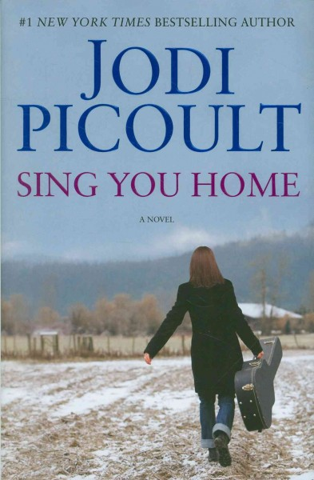 Linda says: Picoult tackles head on the issues of infertililty, gay parenting, alcoholism and the influence of Evangelical churches. I guarantee this book will generate lots of discussion and controversy.
The Immortal Life of Henrietta Lacks by Rebecca Skloot $16.99 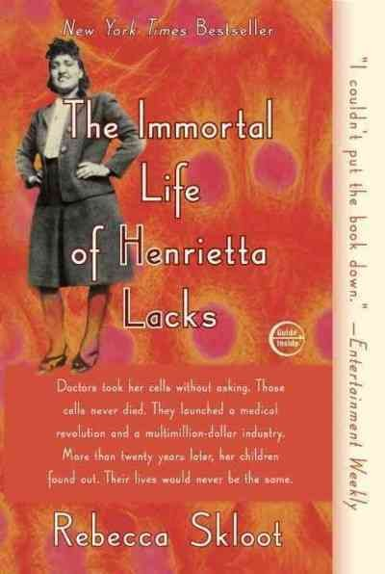 Linda says: Ten years of research into the origins of the HeLa cells, the most famous cells of all time in scientific/medical circles, have Skloot writing the best book I've read in a long time. Skloot outlines how these cervical cancer cells were taken from Henrietta, an impoverished, illiterate black woman, without her permission or without any compensation to her survivors. She meticulously narrates the saga of the great medical advances made possible by the HeLa cells and the unbelievable money made off of them by the scientific community while unfolding the story

of Henrietta's family, most too poor to seek medical attention from these same clinics and doctors when their health required it. This would make a great book club selection for women's
or men's groups, who would find much to discuss here.

Jody: Hands that Heal by Echo Bodine $13.95 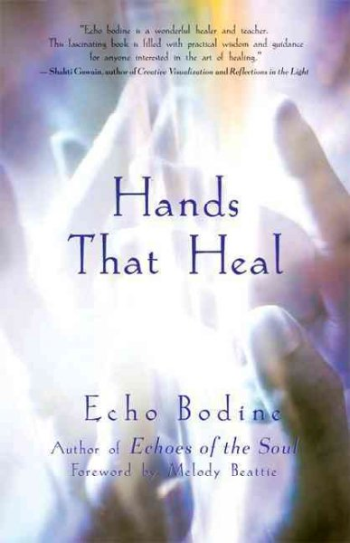 Zen Life: An Open-at-Random Book of Guidance
by Daniel Levin $14.95 

Mama, Why? by Karma Wilson $16.99 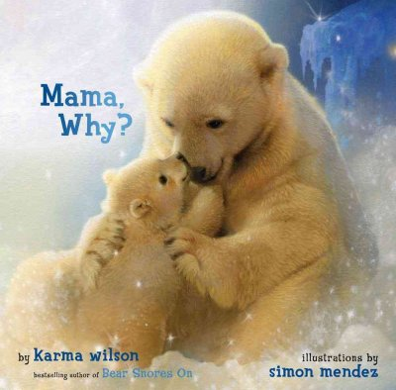 Jody says: Beautiful picture book with soft verse – perfect bedtime book!

Sally: The gift of my recent foot surgery is lots of time to read. Here are some of the books I've read with an ice pack on my foot!: The Good Son by Michael Gruber $14.99 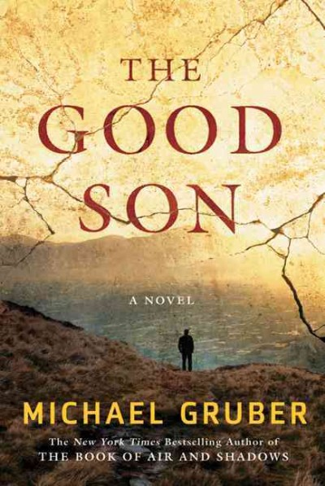 Sally says: This novel is set primarily in Pakistan, where the members of a peace conference have been kidnapped by terrorists. A fast-paced thriller, it also explores the cultural differences which inform much of the tension in our post9/11 world. Michael Gruber is also the author of The Book of Air and Shadows. Bitter in the Mouth by Monique Truong $25 ($15 paperback will be released in August) 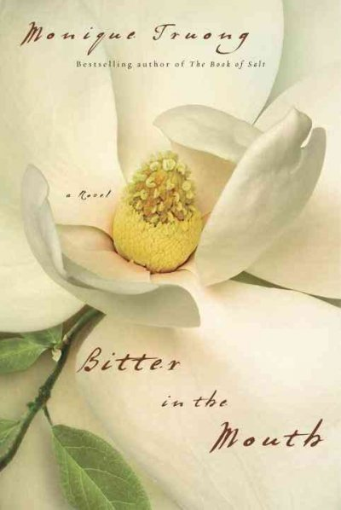Sally says: Linda Hammerick, the main character of this novel, can taste words--and that's only the beginning of the ways she feels different from the people around her. The story deals with themes of the meaning of family, the nature of our connections to one another, and the ways our personal history impacts our entire life. One Amazing Thing by Chitra Divakaruni $13.99 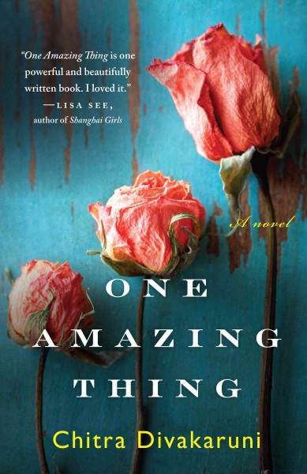Sally says: Nine people are trapped in an office in San Francisco during an earthquake. After organizing themselves to deal

with their situation, they decide to pass the time by storytelling. Each person tells the tale of "one amazing thing" in his or her life. This wonderful book will be one of the first picks for the Sister Wolf Book groups this spring. *One of Jen’s picks for this year’s Night-In! Emily: Harry Potter and the Deathly Hallows by J.K. Rowling $14.99 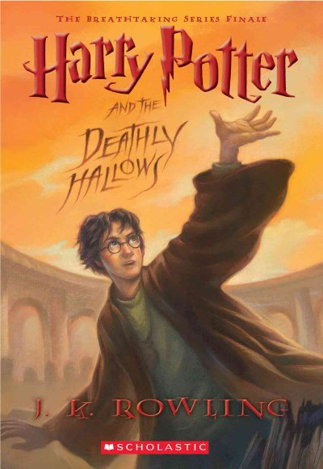 The 19th Wife by David Ebershoff $15 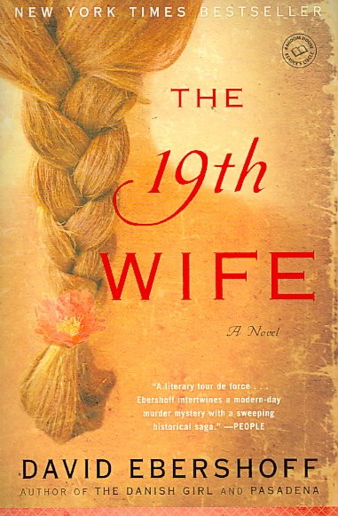
Jen: Wingshooters by Nina Revoyr $15.95 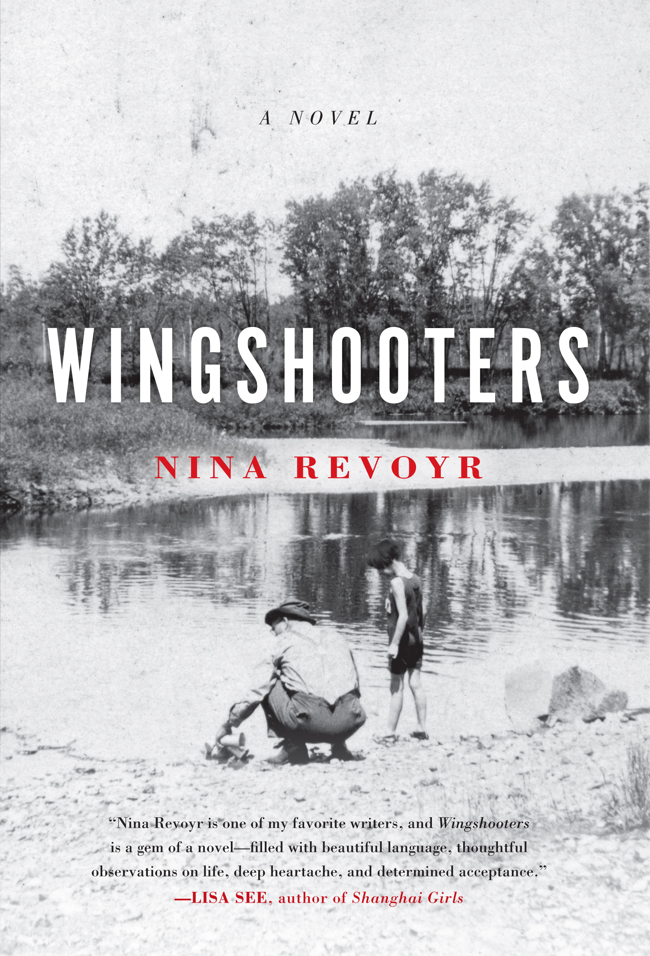 Jen says: I am completely smitten with this book! To see my blog entry about this book, go to: http://beaglebooks.blogspot.com/2011/03/wingshooters.html

Cherished: 21 Writers on Animals They Have Loved and Lost edited by Barbara Abercrombie $14.95 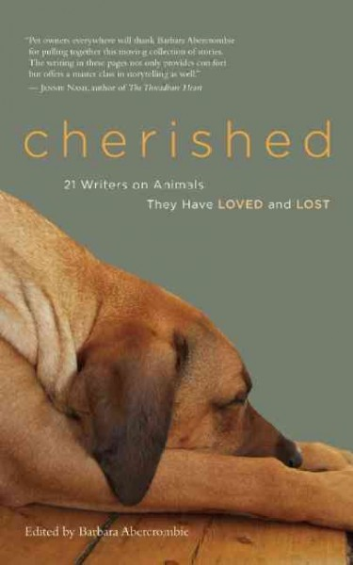 Jen says: I happened upon this book on a day I was feeling particularly sad about missing Little Pine (our collie mix who got her wings last November). This book is a wonderful collection of essays about pets. This is one of those books that you pick up, read an essay, let the book sit a while, then pick it up again later and read another. Contributing writers include Anne Lamott, Jane Smiley, Jacqueline Winspear, Carolyn See, Mark Doty, and many others. * All royalties will be donated to Best Friends Animal Society.
Tinkers by Paul Harding $14.95 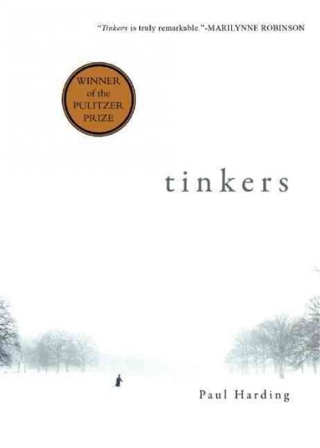

Youth Yak
by Jen
The Blue Chameleon by Emily Gravett $16.99
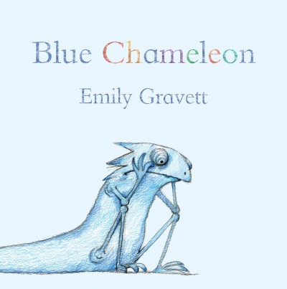
Emily Gravett is one of my favorite picture book author/illustrators. Her latest book is about a blue (lonely) chameleon who meets a number of

objects and animals in different colors and styles and assumes its color/style, but none of these is quite right. (For example, a purple spotted ball). The text is very sparse but effective, the pictures are wonderful and the ending, which I of course won’t give away!, is just right.

Book Group Reads
Beagle Books Womens Book Group
Wednesday, April 13th at 6PM:
Tinkers by Paul Harding $14.95

Beagle Books Mens Book Group
Tuesday, March 19th at 8AM:
Big Burn: Teddy Roosevelt and the Fire That Saved America by Timothy Egan $15.95
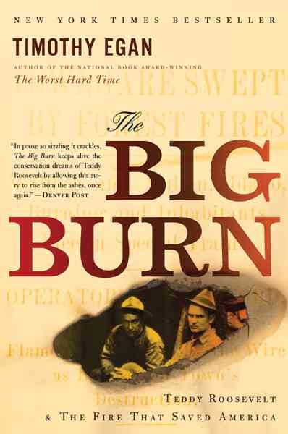

Blue Stocking Society
Shadow Tag by Louise Erdrich $14.99 

