So, you’ve been holding your breath since August 1st, clenching a coffee mug, staring at the computer screen and muttering, “Where IS that newsletter??” Well……. it’s here now. Hope you didn’t pass out waiting. We’re clinging to the excuse that Taste of Dorset was August 1st and we were very busy.


Kate Ledger Book Signing

Kate Ledger, author of Remedies will be at Beagle Books on Saturday, August 14th at noon! Assuming you haven’t committed every word of every newsletter to memory, allow us to repeat Jen’s review from our January newsletter: I LOVE this book! It is SO well-written! …The author so unabashedly delves into the consequences of grief left ungrieved. Simon and Emily Bear is a middle-aged couple with one teenage daughter. Prior to the daughter’s birth, the couple had a son who died as an infant. Simon, a doctor, buries himself in work. When Simon thinks he’s found a cure for chronic pain, he becomes so immersed in his work that he teeters dangerously close to the edge of insanity. Emily has repressed her emotions so completely that it is only with the help of a former lover that her stuffed feelings have any chance of airing. …Fall in love with the beauty of well-written sentences and the incredible evolution the human soul can make, you must read this!

Park Rapids Renewal Project

Photo courtesy of Good Life Café in Park Rapids.
You may be aware that Park Rapids is undergoing some exciting changes. As of August 2nd, Main Street, between Highway 34 and 5th Street, is closed to traffic. Not to worry, Beagle Books is still completely accessible! 3rd Street IS open (except for the part that crosses Main Street of course). We encourage you to keep shopping at your favorite stores in downtown Park Rapids (those on Main Street are using back entrances). There is information about the renewal project available at Beagle Books and many other stores in Park Rapids.

Midwest Connections Picks 
A late July Pick:
Every Natural Fact: Five Seasons of Open-Air Parenting by Amy Lou Jenkins $14.95

Every Natural Fact: Five Seasons of Open-Air Parenting is a narrative of mother-and-son nature outings across the state of Wisconsin. In a style that blends the voices of Janisse Ray and Annie Dillard, a mother and son explore parallels in the world of people and nature. The interconnected chapters stand on their own and build upon each other. These explorations of natural history, flora

and fauna, and parenting themes demonstrate that the mythic thread that winds through everything can still be found, even in a world of wounds.

August Picks:
The Personal History of Rachel DuPree: A Novel
by Ann Weisgarber $25.95
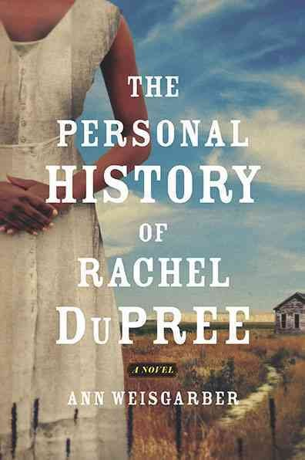
When Rachel, hired help in a Chicago boardinghouse, falls in love with Isaac, the boardinghouse owner's son, he makes her a bargain: he'll marry her, but only if she gives up her 160 acres from the Homestead Act so he can double his share. She agrees, and together they stake their claim in the forebodingly beautiful South Dakota Badlands.
Fourteen years later, in the summer of 1917, the cattle are bellowing with thirst. It hasn't rained in months, and supplies have dwindled. Pregnant, and struggling to feed her family, Rachel is isolated by more than just geography. She is determined to give her surviving children the life they deserve, but she knows that her husband, a fiercely proud former Buffalo Soldier, will never leave his ranch: black families are rare in the West, and land means a measure of equality with the white man. Somehow Rachel must find the strength to do what is right-for herself, and for her children.
Reminiscent of The Color Purple as well as the frontier novels of Laura Ingalls Wilder and Willa Cather, The Personal History of Rachel DuPree opens a window on the little-known history of African American homesteaders and gives voice to an extraordinary heroine who embodies the spirit that built America.

Starting from Scratch by Susan Gilbert-Collins $15
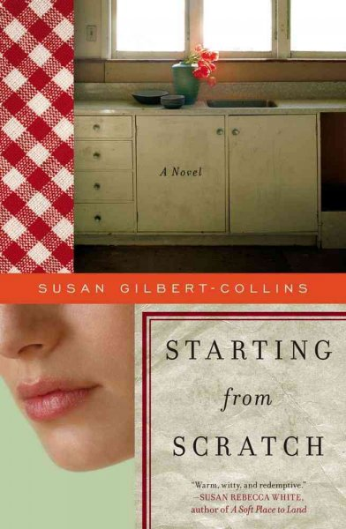
Why is someone who just defended her doctoral dissertation still wasting her time at her childhood home, two months after her mother's funeral, making coq au vin and osso buco? Olivia Tschetter, the youngest of four high-achieving South Dakotan siblings, is not returning to "normal"—or to graduate school— quickly enough to suit her family. She wants only to bury herself in her mother's kitchen, finding solace in their shared passion for cooking.
Threatened with grief counseling, Olivia accepts a temporary position at the local Meals on Wheels, where she stumbles upon some unfinished business from her mother's past—and a dark family secret. Startling announcements from two siblings also challenge the family's status quo. The last thing she needs is a deepening romantic interest in a close but platonic (she thought) friend.
But while Olivia's mother is gone, her memory and spirit continue to engage Olivia, who finds herself daring to speak when she would never have spoken before. Told with humor and compassion, Starting from Scratch explores the shifting of family dynamics in the wake of shattering loss and the healing power of cooking.
Used Books As you might have noticed, both Beagle Books and Sister Wolf Books are carrying used books. If you’re wondering if we buy used books from customers – YES. We’re mostly interested in paperback fiction. We pay in store credit. For more information, contact Jennifer: beagle-books@arvig.net or 237-2665.

Staff Picks Sally: Major Pettigrew's Last Stand by Helen Simonson $25 
Half the Sky: Turning Oppression Into Opportunity for Women Worldwide by Nicholas D. Kristof on audio $34.95 (paperback is $15.95)
Jennifer: Chef by Jaspreet Singh $14

Olive Kitteridge by Elizabeth Strout $14
Bookbinding, and the Care of Books: A Handbook for Amateurs, Bookbinders & Librarians by Douglas Cockerell $18.99 Jennifer says: This past spring, I began an apprenticeship with bookbinder David Farkell. In July, David suffered a heart attack and later died. David had loaned me his copy of this book.

Hannah:
The Bolter by Frances Osborne $15.95


*See Youth Yak for more of Hannah’s reads

Cindie:
My Stroke of Insight: A Brain Scientist's Personal Journey by Jill Bolte Taylor. $15
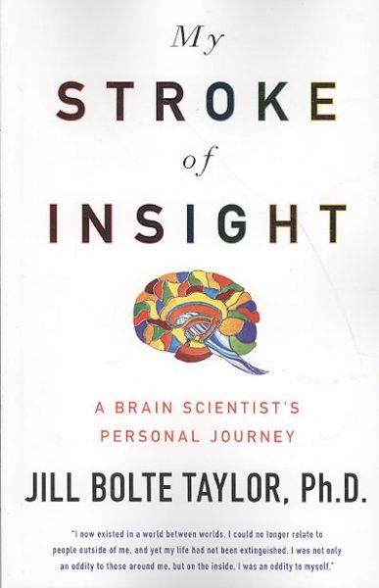 Cindie says: My father had a small stroke a few weeks ago. Jill's account of her stroke and recovery is very informative and inspiring.
The Wizard of Oz by Frank L. Baum $14.99 Cindie says: I've never read the original story, but having granddaughter, Jager for a few weeks this summer has been inspiring. There is a reason this is a classic!
Brady Brady Brady: The Complete Story of the Brady Bunch As Told by the Father/Son Team Who Really Know by Sherwood and Lloyd Schwartz. $24.95 Cindie says: This memoir co-written by the creator of the Brady Bunch and his son speaks to my Cindy Brady soul! Besides the inside skinny on how the show came to be and fun swipes at Robert Reed for being such a royal pain, it also offers insight into the creative process and how T.V. shows get made. Who knew that Marcia Brady getting hit in the nose by a football is one of the top 50 TV moments of all time--right up there with JFK getting shot and the landing of the moon!

Jody: You with the Stars in Your Eyes by Deepak Chopra $14.95 

Gail:
Little Bee by Chris Cleave $14
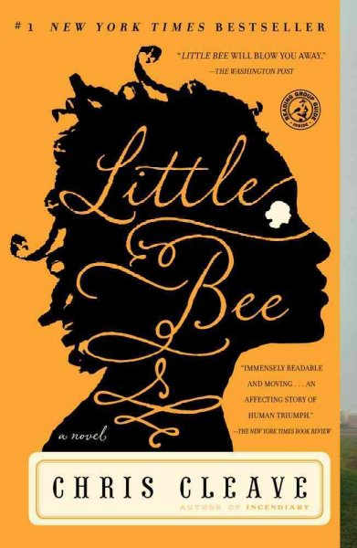
Quickening by Michelle Hoover $14.95
Breakfast with Buddha by Roland Merullo $13.95 Gail says: Watch for the chapter where the travelers eat at Schwarzwald's in Park Rapids!

Youth Yak
Linger by Maggie Stiefvater
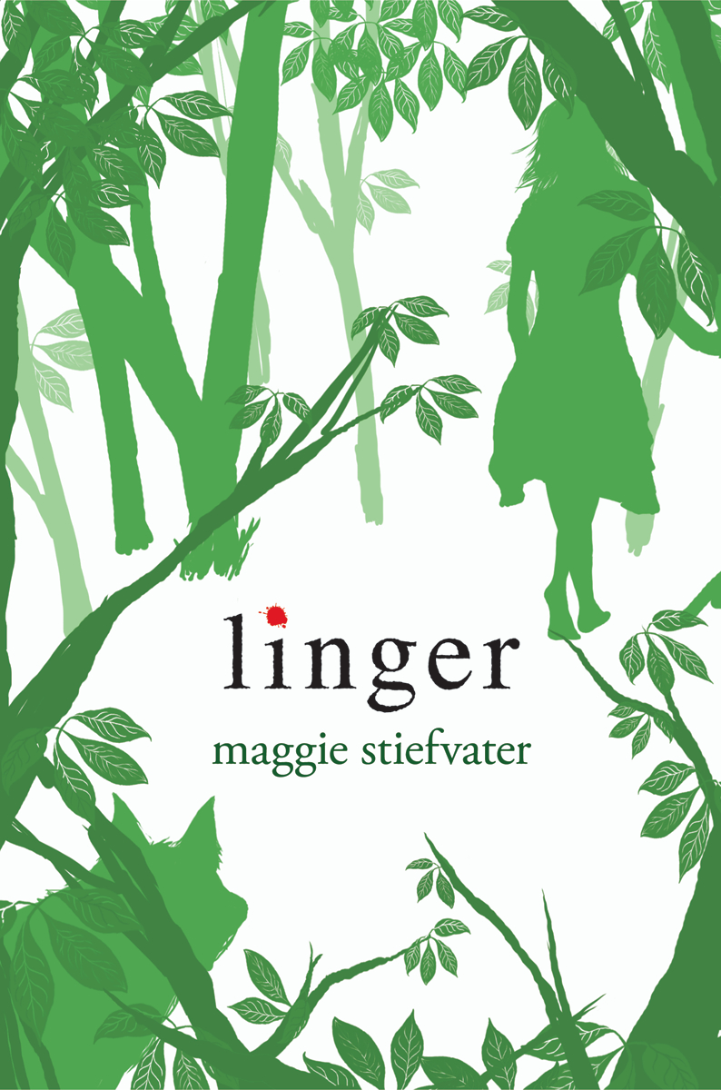
Sam, who spent most of his life as a wolf, has undergone an unlikely cure and no longer transitions between fur and skin as the temperature changes from cold to hot. This should be a happy time for Sam and true-love Grace, but just as he begins to trust his new human life, Grace feels her humanity slipping away. Sam’s focus is split between worry for Grace and his role as caretaker of the werewolf pack, which for the first time in years includes new members.
Stiefvater continues what she started in Shiver, and readers will definitely want to read it before diving into this equally appealing sequel. As in the opener, this story’s tension stems from watching sympathetic characters cope with what

appears to be a hopeless situation. Although this was resolved to a point by the first book’s ending, this follow-up flips that resolution on its head and sets up a situation that leaves readers hanging in anticipation for the next installment. Note to Facebook Junkies: Maggie Stiefvater has a GREAT presence on Facebook. Maggie posts often and is lots of fun! Due to Jennifer being a Facebook junkie, Beagle Books scored some Shiver t-shirts from Maggie and gave them away to the first buyers of Linger! Thanks Maggie!
Hannah’s Picks: House of Night series by P.C. and Kristin Cast Hannah says: An excellent alternative to Twilight.
The Cardturner by Louis Sacchar Hannah says: Love love it! I really want to learn how to play Bridge now.
Shiver by Maggie Siefvater
Hunger Games by Suzanne Collins Hannah says: Everything it's been built up to be. Amazing.

Book Group Picks

Beagle Books Mens Book Group
Tuesday, August 17th at 8AM: Still Alice by Lisa Genova $15
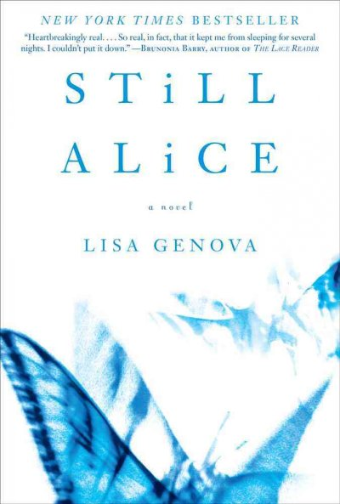 *Note: This book group meeting will be at the home of one of the book group members – please call Beagle Books for directions.

Beagle Books WOMENS Book Group
It’s time to re-convene! We’ll meet THURSDAY, AUGUST 26TH at 7PM to pick books and meeting times for the fall. Feel free to email Jen with suggestions: beagle-books@arvig.net

Sister Wolf Womens Morning Group
Wednesday/Thursday, August 4th/5th at 9AM: Little Bee by Chris Cleave $14
Wednesday/Thursday, August 18th/19th at 9AM: Olive Kitteridge by Elizabeth Strout $14
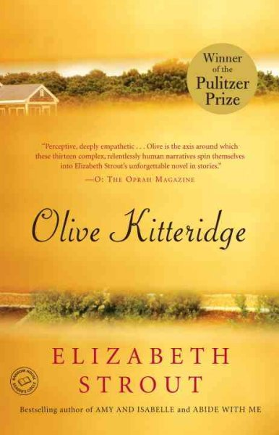

Sister Wolf Womens Evening Group Thursday, August 12th at 7PM: Valeria’s Last Stand by Marc Fitten $15 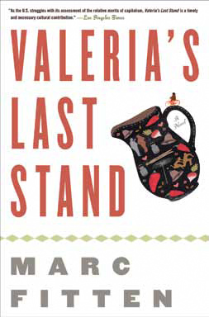
Thursday, August 26th at 7PM:
That Old Cape Magic by Richard Russo $15
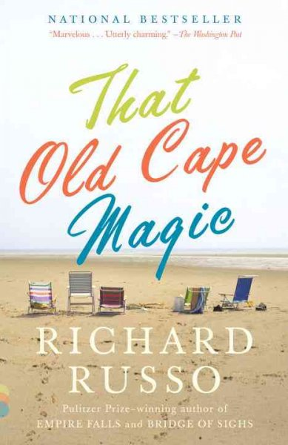

One More Thing There is a possibility that Beagle Books name could change…..to…
Beagle Books & Bindery ☺
We’ll keep you posted.

