Lil Pine
by Jen

It is with great sadness that I tell you our beloved collie mix greeter, Lil Pine, has died. Thank you to all of you who gave her so much love at Beagle Books. She loved being at the bookstore and it was because Beagle customers were so good to her. It saddened me to stop bringing her, but she had difficulty breathing, occasionally had accidents, and towards the very end lost a lot of weight (she was being eaten by cancer). I was afraid her condition might frighten our children customers. If you have memories or pictures you’d like to share, we’d love to know. Please share at my blog: http://beaglebooks.blogspot.com/2010/11/fly-high-lil-pine.html

A Happier Note
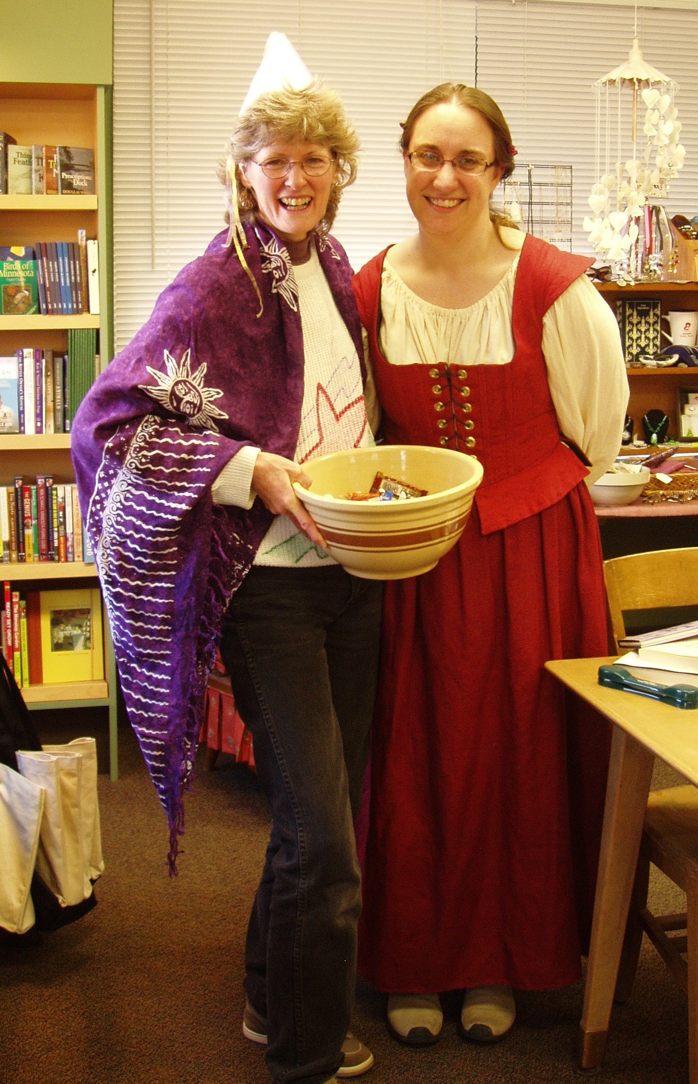 Fairy Princess Jo and Lady Jennifer during the Downtown Trick or Treating on Oct. 30th (Photo courtesy of Jennie Anderson of Northwoods Press).

Events
Local author Rod Hunt will be signing copies of his newest book, Sem: The Ordinary Mind at Beagle on Saturday, November 6th at noon.


Local poet Marion Holtey will join us for Arts Downtown (3rd Thursday s of the month) on November 18th 5-7PM to read from her new book, Seasons of Light!

Will Weaver will be at the Park Rapids Library on Thursday, November 18th from 6:30 to 8:00pm for discussion and questions on his new book, Last Hunter, which was chosen as the Park Rapids Community Read this fall!
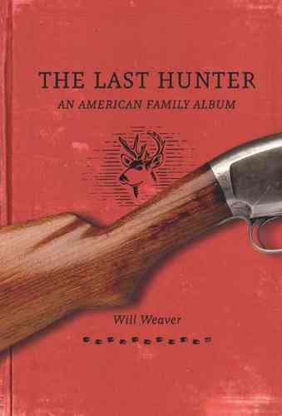

Jingle Bells! 
Yep, it’s that time again! Shop downtown and collect jingle bells tickets for your chance to $5,000 or $1,000 or other prizes! At Beagle Books, we give out double tickets every day!

Midwest Connections Picks 
Swallowing the Soap: New and Selected Poems by William Kloefkorn $26.95

This volume, the first to span the forty-year career of Nebraska state poet William Kloefkorn, brings together the best-known and most beloved poems by one of the most important Midwestern poets of the last half century. Collecting work from limited editions and hard-to-find books, along with Kloefkorn’s most anthologized poems, Swallowing the Soap is an indispensable one-volume compendium of the work of a major American poet.

Dakota, or What’s a Heaven For by Brenda K. Marshall $24.95
 A nineteenth-century epic. Imagine a Midwestern Middlemarch, if you will, that conjures the Gilded Age in a succession of sweeping panoramas and intimate portraits. Brenda Marshall puts me in mind of an American Sarah Waters, a writer at once in persuasive command of history and simultaneously able to slip beneath its skin to the story beneath. This is a vibrant, teeming work, filled with feeling, intelligence and ultimately, grace. -Peter Ho Davies (author of The Welsh Girl)

Christmas with Tucker by Greg Kincaid $15.99
 It is the winter of 1962, and Kansas is hit with one of the worst blizzards in its history. It is during this cruel season that twelve-year-old George is called upon to endure more than even most grown men could withstand—the death of his father and the upkeep of the family farm that is his legacy.
When his mother and sisters leave for Minnesota, George has only his grandparents and the companionship of Tucker, an Irish setter, to help him persevere through these most difficult challenges. Can he find the strength to walk the road that leads to healing, finding his true self and ultimately becoming a man? A coming-of-age story for readers of all ages, Christmas with Tucker is a classic Christmas story about a young man’s love for his dog, his family, and his farm.

Midwest Booksellers Association Catalog

Every year, the Midwest Booksellers Association puts together a great catalog of books (just in time for the Holidays!). Those of you who subscribe to the Park Rapids Enterprise, you will be getting a copy inserted in your newspaper the Saturday following Thanksgiving. You can also access the catalog online:
http://www.midwestbooksellers.org/site/wp-content/uploads/2010/10/2010-MBA-Catalog_FINAL.pdf
Check it out, it has GREAT titles!

NaNoWriMo
To those of you interested in NaNoWriMo (National Novel Writing Month):
Ever want to write a book?
...think you can do it in a month?
Open to anyone with a desire to write, join the international challenge to write your novel in November. Proof copies (bound books with your name on it) are available to those that finish!
50,000 words, one month. Join us!
First meeting date is Tues, October 26th at 6pm. This is an introduction to the NaNoWriMo program and learning how to get set up; writing tips, tricks, and resources; and a meet and chat opportunity.
We will also be meeting on Tuesdays (Nov 9, 16, 23, 31 - no class Nov 2nd due to elections) to have a chance to see how people are going and get any help that is needed.
On the 31st, we'll be having a celebration for those that finished, those that wrote more than they could have imagined, and those that tried!
Sign up through prbschools.org (click on Community Education). There is a minimal fee of $5 to help cover supplies and building use. The class will be located in the high school in Pine River, MN.
cordria@hotmail.com

Staff Picks
Kathy:
Hotel on the Corner of Bitter and Sweet by Jamie Ford $15
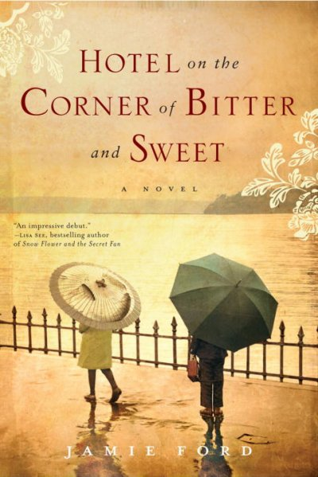 Note: This was a Sister Wolf Books Women’s book group selection this past summer and has been a bestseller at both Sister Wolf and Beagle – our customers are LOVING it!

Linda: Half Broke Horses: A True-Life Novel by Jeannette Walls $15
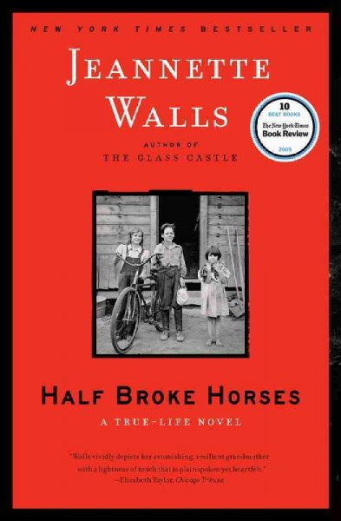 The Story Sisters by Alice Hoffmann $15
Sally: Adam & Eve by Sarah Jeter Naslund $26.99 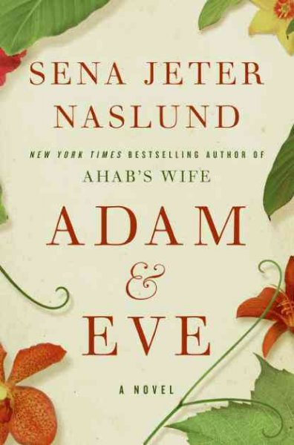
Freedom by Jonathan Franzen $28
Gail: Major Pettigrew's Last Stand by Helen Simonson Due out in paperback Nov. 30th! $15
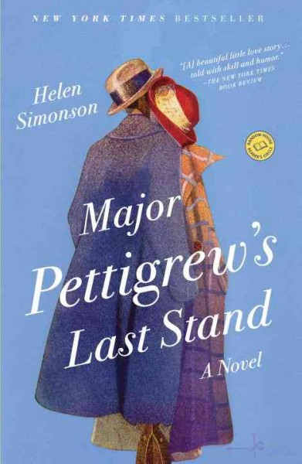
Murder on Warbler Weekend by Jan Dunlap $14.95 Gail says: This is the second book in a series by this Minnesota author. The protagonist is a school guidance counselor and a birder. He takes his Mother bird watching and she finds a dead body! I enjoyed this even though I don't read many mysteries. Taught by America: A Story of Struggle and Hope in Compton by Sarah Sentilles $16 Gail says: After graduating from Yale, Sarah learns nothing prepared her for teaching in a run-down elementary school in Compton, California. An

eye-opener and the sad part is when she goes back several years later nothing has changed. Makes one appreciate our Minnesota schools and our dedicated educators. Memory of Trees: A Daughter's Story of a Family Farm by Gayla Marty $24.95
Jennifer: The Story Sisters by Alice Hoffmann $15 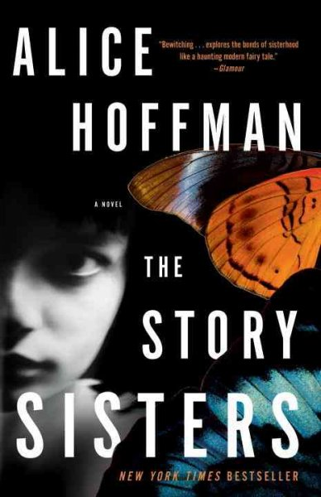 Jen says: My fellow book group members say, “Keep reading! The beginning is a bit peculiar, but it gets SO GOOD!” I’m not too far into the book yet, but I’m enjoying the beginning so I can’t wait for it to get even better! The Lacuna by Barbara Kingsolver on audio $44.99 (paperback is $16.99) Jen says: I started reading the print version of this a while ago, but I couldn’t get into it, which disappointed me because I LOVE Kingsolver! This time I’m letting Barbara Kingsolver read it to me (if you’ve never heard Kingsolver read her own work, she does a great job) and I’m enjoying it a lot more. There is a lot of Russian history that is keeping my attention and the protagonist is so lovable.
Cindie: Transcendent Dreaming: Stepping into Our Human Potential by Christina Donnell, Ph.D. $12.95 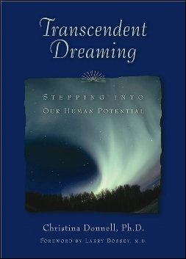

Jody:
Nurturing Spirituality in Children: Simple Hands-On Activities by Peggy Joy Jenkins $15
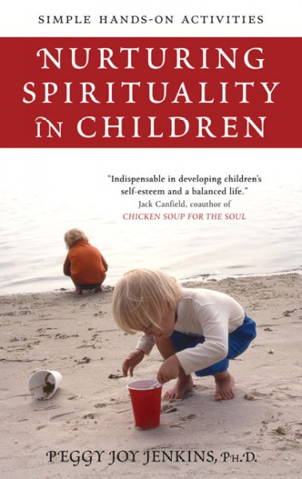
Jo says: Simple hands-on experiments to expand perspective!
Waiting for the Darkness to Lose Interest by Tom Stetzler $12.95

Youth Yak
Featured Title!
Revolution by Jennifer Donnelly $18.99
 BROOKLYN: Andi Alpers is on the edge. She’s angry at her father for leaving, angry at her mother for not being able to cope, and heartbroken by the loss of her younger brother, Truman. Rage and grief are destroying her. And she’s about to be expelled from Brooklyn Heights’ most prestigious private school when her father intervenes. Now Andi must accompany him to Paris for winter break.
PARIS: Alexandrine Paradis lived over two centuries ago. She dreamed of making her mark on the Paris stage, but a fateful encounter with a doomed prince of France cast her in a tragic role she didn’t want—and couldn’t escape.
Two girls, two centuries apart. One never knowing the other. But when Andi finds Alexandrine’s diary, she recognizes something in her words and is moved to the point of obsession.

There’s comfort and distraction for Andi in the journal’s antique pages—until, on a midnight journey through the catacombs of Paris, Alexandrine’s words transcend paper and time, and the past becomes suddenly, terrifyingly present.

Cindie’s Pick:
Plain Kate by Erin Bow $17.99
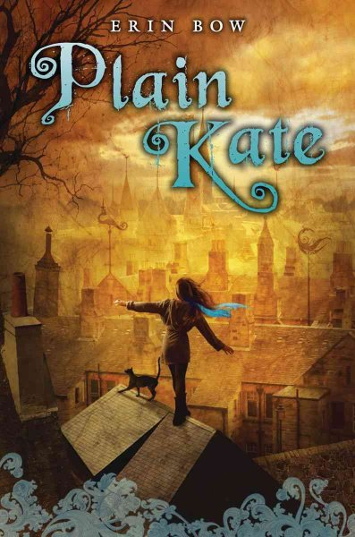 (Is this a cool cover or what??)
Cindie says: Love it! Gypsies, witches and a talking cat that even a dog lover like me could appreciate!

Book Group Picks

Beagle Books Mens Book Group
Tuesday, November 16th at 8AM:
Last Hunter: An American Family Album by Will Weaver $24.95

Beagle Books Womens Book Group
Wednesday, November 10th at 6PM:
Story Sisters by Alice Hoffmann $15

Blue Stocking Society
The French Gardener by Santa Montefiore $15


