Buying Books during Winter
Sister Wolf is sleeping, dreaming of next summer's books and activities. In the meantime, where will you purchase books? Our recommendation is that you patronize the independent bookstore in your area. If none exists, we would love to have your business! You may purchase books or e-books (for ANY device other than the kindle) at competitive prices from our websites (www.sisterwolfbooks.com and www.beagle-books.com) Or, call Beagle Books (218-237-2665) for book suggestions and ordering.

TRADE SHOW!!!!!!!
At the end of September, we did our very favoritest thing in the whole world: we attended the annual Midwest Independent Booksellers Association trade show. This is our chance to talk with other booksellers, meet publishers, meet authors, and talk books, books, books! If a picture is worth 1000 words, here goes thousands:
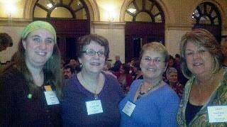
Jen, Sally, Linda & Susan

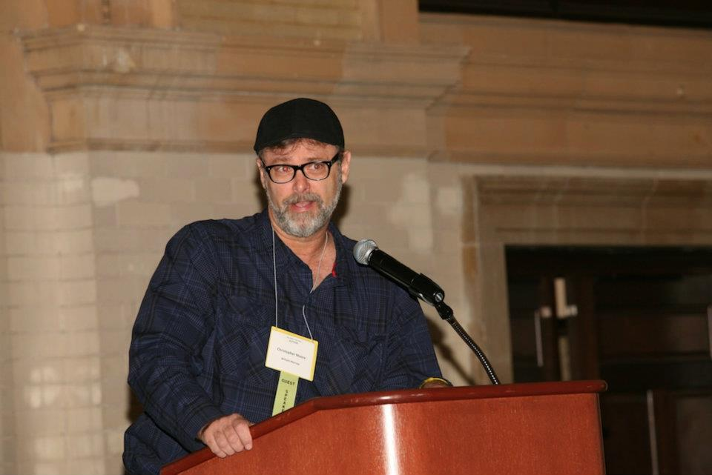
Christopher Moore!

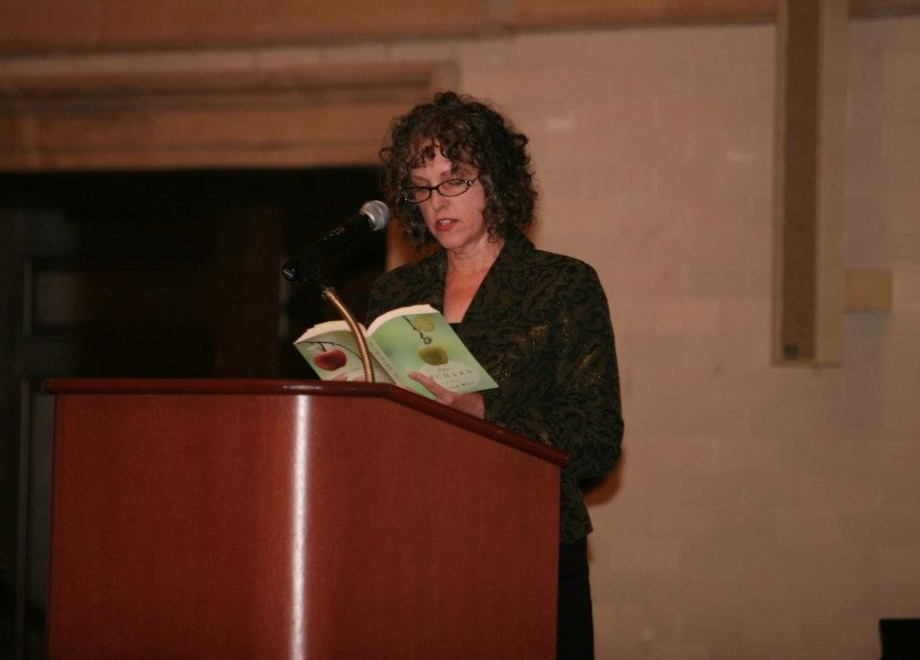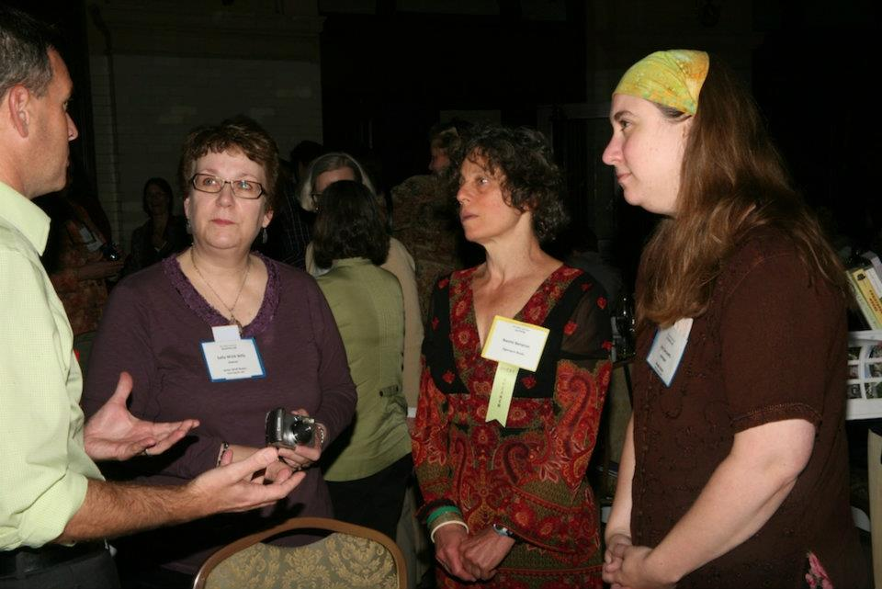
Theresa Weir reading Sally, Naomi Benaron (winner
from The Orchard of the 2012 Belwether Prize!!),
and Jen (Oh, and Craig – but you
probably don’t know Craig ☺)

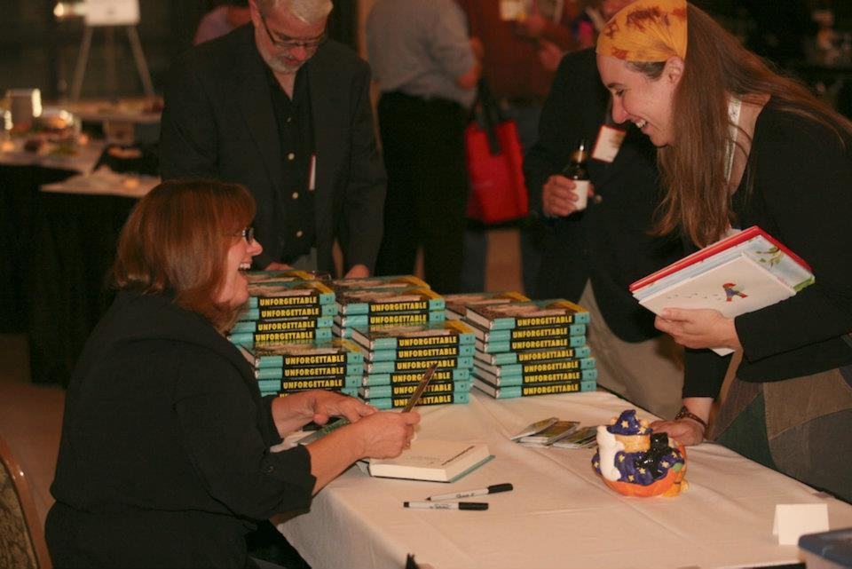
Loretta Ellsworth and Jen

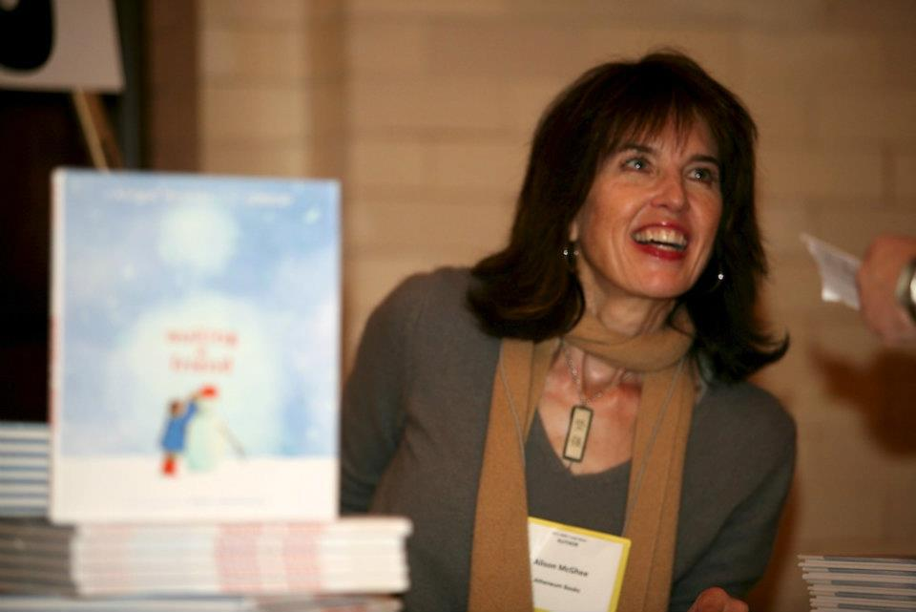
Alison McGhee!

Midwest Connections Picks  October Picks:
Adult picks are listed below, children’s picks are listed in Youth Yak

American Boy by Larry Watson 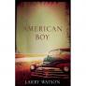 "We were exposed to these phenomena in order that we might learn something, but of course the lessons we learn are not always what was intended." So begins Matthew Garth's story of the fall of 1962, when the shooting of a young woman on Thanksgiving Day sets off a chain of unsettling events in small-town Willow Falls, Minnesota. Matthew first sees Louisa Lindahl in Dr. Dunbar's home office, and at the time her bullet wound makes nearly as strong an impression as her unclothed body. Fueled over the following weeks by his feverish desire for this mysterious woman and a deep longing for the comfort and affluence that appears to surround the Dunbars, Matthew finds himself drawn into a vortex of greed, manipulation, and ultimately betrayal. Immersive, heart-breaking, and richly evocative of a time and place, this long-awaited novel marks the return of a great American storyteller.
In Caddis Wood by Mary F. Rockcastle 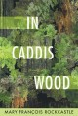 Told from the alternating perspectives of a husband and wife, In Caddis Wood explores the competing rhythms of romantic love, family life, and professional ambition, refracted through the changing seasons of a long marriage. Beneath the surface, affecting their collective future, beats the resilient and endangered heart of nature. Hallie’s career as a poet has always come second to her family, while Carl’s life has been defined by his

demanding and internationally acclaimed work as an architect. The onset of a debilitating illness and the discovery of Hallie’s cache of letters from another man set Carl reeling and cause him to question not only his previously unshakable belief in himself but also his faith in Hallie’s devotion. As the memories multiply and the family gathers at their longtime summerhouse in the woods of Wisconsin, Hallie and Carl’s grown-up daughters offer unexpected avenues toward forgiveness and healing.
The Hum and the Shiver by Alex Bledsoe 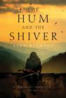 No one knows where the Tufa came from, or how they ended up in the Smoky Mountains of East Tennessee, yet when the first Europeans arrived, they were already there. Dark-haired, enigmatic, and suspicious of outsiders, the Tufa live quiet lives in the hills and valleys of Cloud County. While their origins may be lost to history, there are clues in their music—hints of their true nature buried in the songs they have passed down for generations. Private Bronwyn Hyatt returns from Iraq wounded in body and in spirit, only to face the very things that drove her away in the first place: her family, her obligations to the Tufa, and her dangerous ex-boyfriend. But more trouble lurks in the mountains and hollows of her childhood home. Cryptic omens warn of impending tragedy, and a restless “haint” lurks nearby, waiting to reveal Bronwyn’s darkest secrets. Worst of all, Bronwyn has lost touch with the music that was once a vital part of her identity. With death stalking her family, Bronwyn will need to summon the strength to take her place among the true Tufa and once again fly on the night winds. . . .

Staff Picks
Sally: In the Garden of Beasts: Love, Terror, and an American Family in Hitler's Berlin by Erik Larson on audio 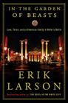
American Boy by Larry Watson Sally says: This is a coming of age story, set in Minnesota during the 60's. Watson is the author of Montana 1948.
Unbroken: A World War II Story of Survival, Resilience, and Redemption by Laura Hillenbrand 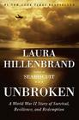
Alice I Have Been by Melanie Benjamin 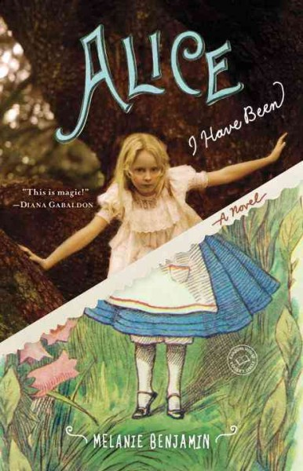 Sally says: Historial fiction,
based on the life of the the woman who was the inspiritation for Alice in Lewis Carroll's Alice in Wonderland. The book was the final pick for the season for Sister Wolf's book groups; the discussion was lively and wide-ranging.

Gail:
The Good Samaritan Strikes Again by Patrick F. McManus 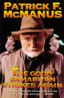 Gail says: Old book, but laughs on every page!
Alice I Have Been by Melanie Benjamin
Life Would be Perfect if I Lived in that House by Meghan Daum 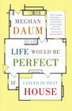
Evolution of Faith: How God Is Creating a Better Christianity by Philip Gulley 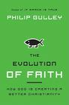
Camel Bookmobile by Masha Hamilton 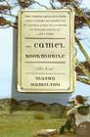 Gail says: Yes, it's Masha not Marsha. I think this would be a great choice for book clubs!

Libraries of Minnesota 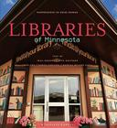 Gail says: This is not just a picture book. There is some great reading from a variety of Minnesota authors about their memories of libraries as they were growing up.
The Immortal Life of Henrietta Lacks by Rebecca Skloot
 Gail says: This title is on our Methodist Women's book list for this year!

Jen:
The Tower, the Zoo, and the Tortoise by Julia Stuart

Stalked by Brian Freeman on audio 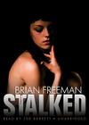

Jamie:
Fallout by Ellen Hopkins 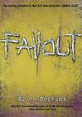
Linda: Turn of Mind by Alice LaPlante 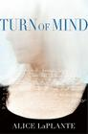 Linda says: Dr. Jennifer White, 64, an orthopedic surgeon, is suffering from Alzheimer's and is a person of interest in the death of her best friend, Amanda. LaPlante's book is part mystery and in my opinion a terrific narrative of the progression of this hideous disease.
Sheepish: Two Women, Fifty Sheep, and Enough Wool to Save the Planet by Catherine Friend 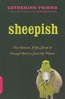 Linda says: Friend, author of Hit by a Farm and The Compassionate Carnivore as well as seven children's books and three novels, had me laughing out loud on the first page as she writes about the joys, the trials and the environmental benefits to the world of raising sheep, llamas and various other animals on the farm she shares with her partner of 28 years.

Jo: Wonderstruck by Brian Selznick 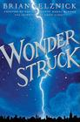 See Youth Yak for more info about this title! Stress ( Chicken Soup for the Soul Healthy Living) by Jack Canfield, Leslie Godwin 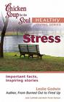 Freeing Our Families from Perfectionism by Thomas S. Greenspon 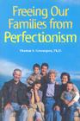
Youth Yak
by Jen
Wonderstruck by Brian Selznick Ben and Rose secretly wish their lives were different. Ben longs for the father he has never known. Rose dreams of a mysterious

actress whose life she chronicles in a scrapbook. When Ben discovers a puzzling clue in his mother’s room and Rose reads an enticing headline in the newspaper, both children set out alone on desperate quests to find what they are missing. Set fifty years apart, these two independent stories—Ben’s told in words, Rose’s in pictures--weave back and forth with mesmerizing symmetry. How they unfold and ultimately intertwine will surprise you, challenge you, and leave you breathless with wonder. Rich, complex, affecting, and beautiful--with over 460 pages of original artwork--Wonderstruck is a stunning achievement from a uniquely gifted artist and visionary. Note from Jen: This is an EXCELLENT read-aloud!! When Megan and I read it together, I read the text and she explained the pictures. We LOVE it!!
Bluefish by Pat Schmatz 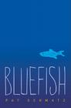 Thirteen-year-old Travis has a secret: he can’t read. But a shrewd teacher and a sassy girl are about to change everything. Travis is missing his old home in the country, and he’s missing his old hound, Rosco. Now there’s just the cramped place he shares with his well-meaning but alcoholic grandpa, a new school, and the dreaded routine of passing when he’s called on to read out loud. But that’s before Travis meets Mr. McQueen, who doesn’t take "pass" for an answer—a rare teacher whose savvy persistence has Travis slowly unlocking a book on the natural world. And it’s before Travis is noticed by Velveeta, a girl whose wry banter and colorful scarves belie some hard secrets of her own.

Book Group Reads
Beagle Books Women’s Book Group
Thursday, October 13th at 6PM:
Grapes of Wrath by John Steinbeck
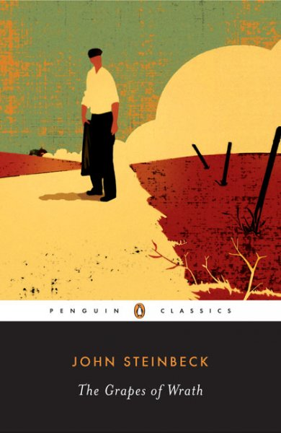 If you find yourself asking, Hey, didn’t you read that LAST month? Well, we had so much fun in September picking books for the season that um, we never actually got around to discussing Grapes.

Beagle Books Men’s Book Group
Tuesday, October 18th at 8AM:
Empire of the Summer Moon: Quanah Parker and the Rise and Fall of the Comanches, the Most Powerful Indian Tribe in American History by S.C. Gwynne 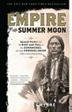
Park Rapids Library Book Club
Friday, October 21st 10:30AM at the library:
The Dry Grass of August by Anna Jean Mayhew
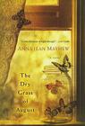

Blue Stocking Book Club
October 12th:
So Big by Edna Ferber 

