Midwest Booksellers Association Trade Show
by Sally

A highlight of the year for the staffs of Beagle Books and Sister Wolf Books is our annual Trade Show. This year’s event was held September 25 and 26 at River Center in St. Paul.

We went down on September 24 to attend a Killer Cocktail Party hosted by the Twin Cities Crime Writers Co-op and Common Good Books (Garrison Keillor’s bookstore.) Highlights of the evening included visiting with our friends Jess Lourey, author of the mystery-of-the-month series, and William Kent Krueger, whose latest book is Heaven’s Keep. We also chatted with Margaret Frazer, author of the Madame Frevisse Tale books and Julie Kramer, author of Stalking Susan and Missing Mark. We saw Garrison Keillor (from a distance, but still!)
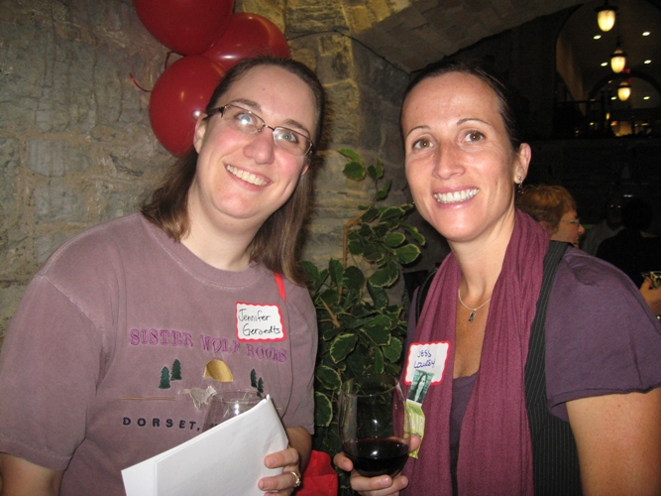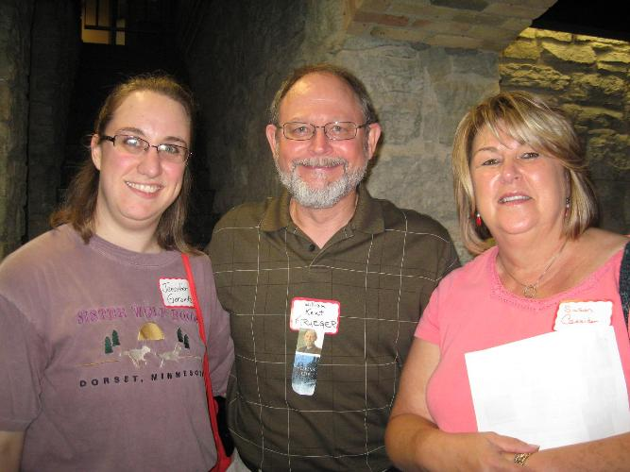
Jennifer with Jess Lourey Jennifer, Krueger, and Susan
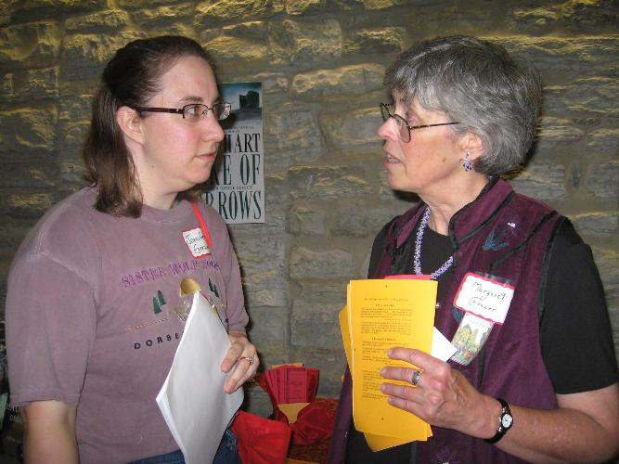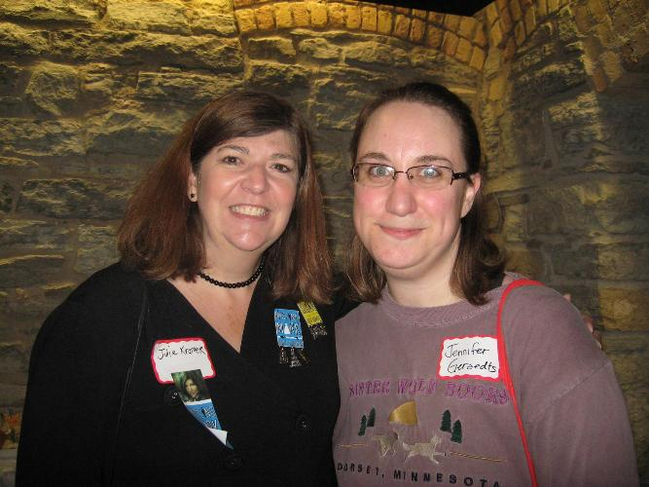
Jennifer with Margaret Frazer Jennifer with Julie Kramer
(Jennifer’s note to self: Next year, get camera out of Sally’s hands).

Friday began with seminars on a variety of topics, and we spread out to cover most of them. Lunch was the popular Moveable Feast. Seven booksellers were seated at each table. Every fifteen minutes, two different authors rotated to join the table. Sally got to sit next to Stephanie Kallos, author of Sing Them Home and Broken for You! Jennifer made sure she sat at a table that

included a visit from Mitch Omer, owner of the
restaurant Hell’s Kitchen and author of Damn Good Food. (If you’re not offended by language,
make sure you ask us to show you the peanut
butter recipe). Chris Farrell, author of The New Frugality, and Stephanie Kallos were speakers for the luncheon.

More seminars filled the afternoon, followed by a reception for authors who won the Midwest Booksellers Choice Awards. Seven authors were
present to accept their awards and deliver short speeches: David Wroblewski (Story of Edgar Sawtelle), Michael Perry (Coop) who made us laugh then cry then laugh again, Freya Manfred (Swimming with a Hundred Year Old Snapping Turtle), Neil Gaiman (The Graveyard Book),
Todd Boss (Yellowrocket), Ingrid Law (Savvy), and Lauren Stringer (Snow). For a complete list of Award winners and their books, go to: http://www.midwestbooksellers.org/midwest-booksellers-choice-awards/

The reception was followed by the Author’s Dinner. Speakers were Elizabeth Berg (Home Safe), Jonathan Safran Foer (Eating Animals), Alex Lemon (Happy: A Memoir), and Kent Meyers (Twisted Tree). Jennifer and I ate with Alex Lemon, a lively conversationalist as well as poet, memoirist, and college professor. Jennifer has already finished reading Lemon’s memoir and will write a review of it when it is released in January.

Saturday began with the Children’s Book and Author Breakfast, featuring M.T. Anderson (Jasper Dash and the Flame-Pits of Delaware), Neil Gaiman (Odd and the Frost Giants), Loren Long (Otis), and Catherine Gilbert Murdock (Front and Center).

The bulk of the day was devoted to the Trade

Show exhibit. Publishers, authors, and vendors
had booths. There were opportunities for conversation with each of them, as well as
informal autographing in the booths. The day
ended with a formal autographing session—over 30 authors were on hand to sign copies of their books.

We returned to Park Rapids tired but happy. Our vehicles were full (really full!) of books and our heads were full of memories. Stop by Beagle
Books to secure copies of the books listed above and to hear stories of our encounters with their authors!

Truffle Cake or Decadent Truffle Cake Recipe
by Gail
A recipe? Yes. Why? Because it was such a hit at the last Sister Wolf Women’s Book Group Potluck that we promised to publish the recipe in our next newsletter. So here it is:

3 cups (18 oz) semisweet chocolate chips
2 sticks (1 cup) unsalted butter
6 large eggs, at room temperature

Heat oven to 425 degrees F.
Coat a 8x3” cake pan with nonstick spray.
Line bottom with wax paper; spray paper. Have a larger roasting pan ready.
Melt chips and butter together; stir until well blended.
Beat eggs in a large bowl with mixer on high for 7 minutes or until tripled and soft peaks form.
Fold in chocolate mixture until blended.
Pour into cake pan.
Place large pan in oven; place cake pan inside.
Pour boiling water into roasting pan to come halfway up sides of cake pan.
Cover cake pan loosely with foil.
Bake 40 minutes. (Cake looks soft but sets when cold).

Cool cake in pan on a wire rack.
Cover and refrigerate 3 hours or until firm.
Invert onto a serving platter; shake down sharply to release cake. Peel off paper.
Sprinkle with confectioners’ sugar and/or cocoa.
Use a stencil when sprinkling the confectioners’ sugar for an extra special pattern on the cake.

Midwest Connections Picks

October Picks:
Hollowing out the Middle: The Rural Brain Drain and What It Means for America by Patrick J. Carr and Maria J. Kefalas $26.95 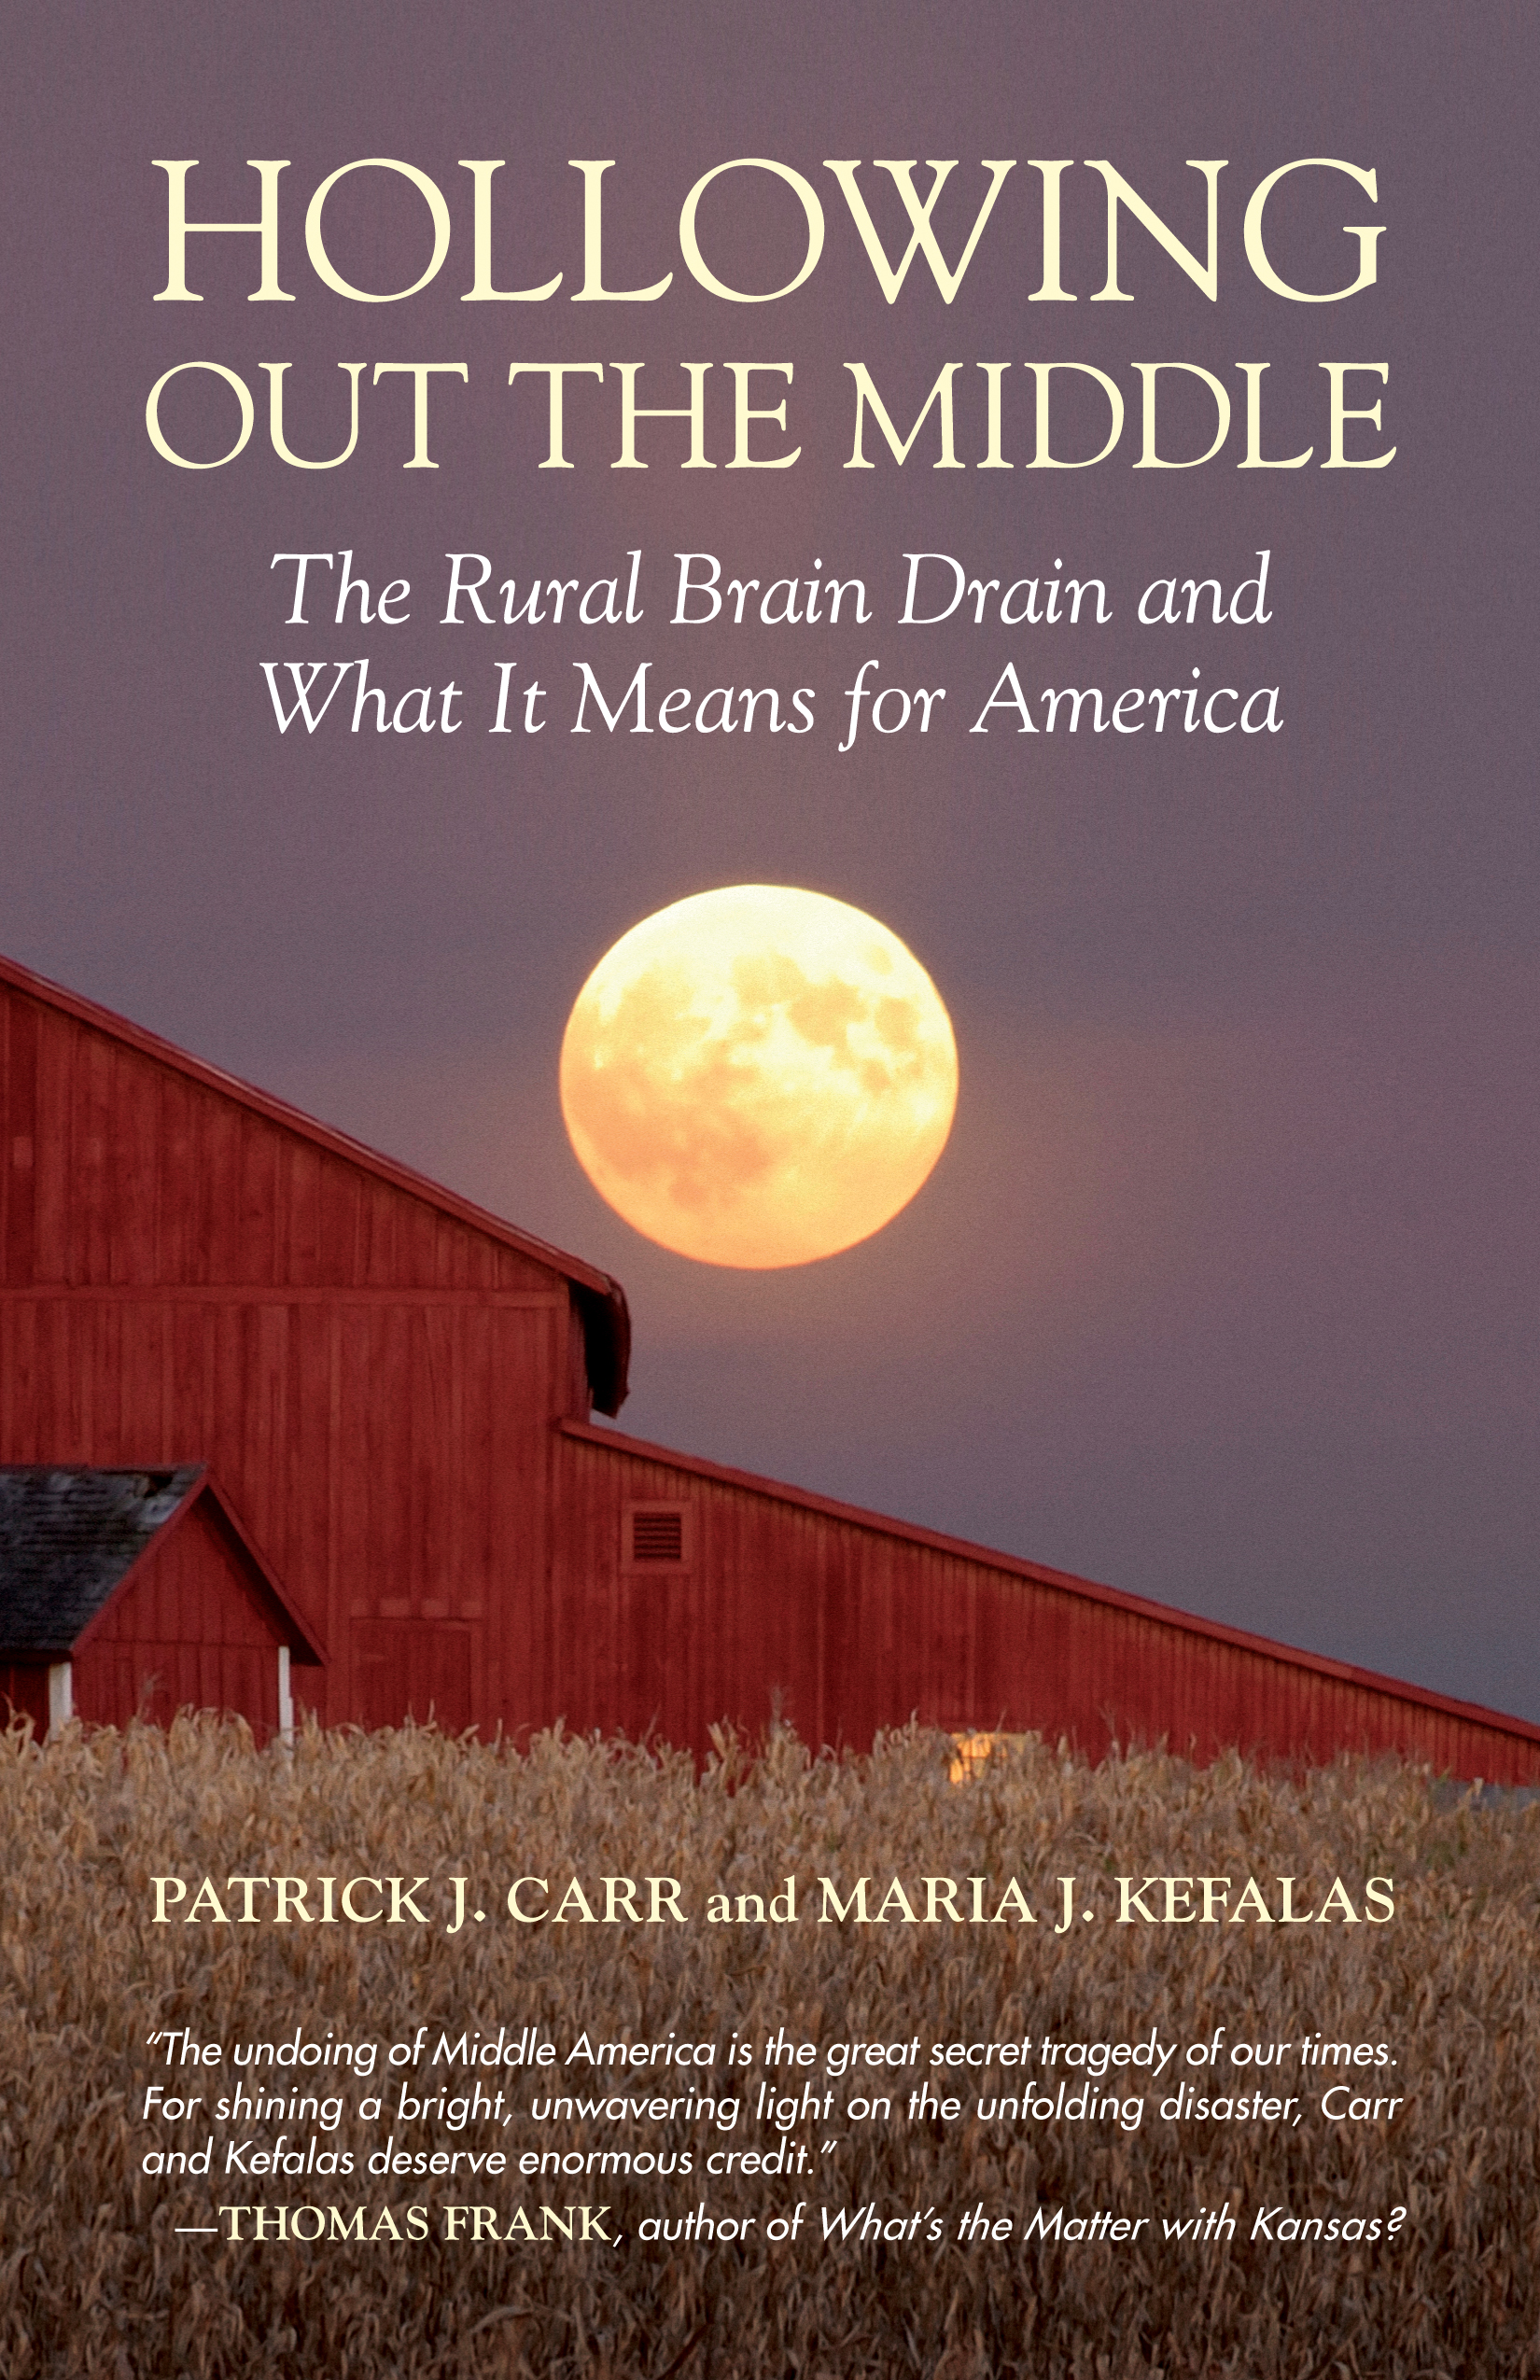 In Hollowing Out the Middle, Carr and Kefalas link the troubling exodus from America’s small towns to the ways young people’s paths are shaped by the adults who surround them as they grow up. They describe a selecting and sorting process in which some of a town’s young are positioned to leave for higher education and lives beyond their rural roots, while others are sidelined, destined to become hourly wage earners in their hometown’s struggling economy. They underscore how this process, long practiced and rarely questioned, is contributing to an out-migration epidemic that is slowly destroying America’s heartland.
Drawing on over a hundred interviews with young Iowans spread over fifteen states, Carr and Kefalas follow the trajectories of college-bound “Achievers”; working-class “Stayers,” trapped in a dying agro-industrial economy; “Seekers,” who

join the military as a way out; and “Returners,” who eventually circle back to their hometowns. They talk to graduates from the University of Iowa who head for cities and high paying jobs; to those who made it through high school, but are stuck making $15 dollars an hour building ambulances and assembling microprocessors; to high school dropouts who put eggs in cartons or slaughter hogs at the meat processing plant, and to enlisted soldiers who joined the military for a number of reasons, from the signing bonus and medical coverage to the promise of a college education.
Noting that it is critical for Americans to understand the importance of investing in rural communities, Carr and Kefalas go on to examine the range of solutions that governors and senators from Maine to Montana have put forth in trying to lure twenty-somethings back home, including tax cuts and credits, loan forgiveness and free land programs, and focusing on “the three Ts”—talent, technology, and tolerance—in building a more vibrant cultural scene. Iowa’s “brain-gain” campaign, they report, has included invitations to attend lavish cocktail parties with the governor and ads promoting the state as more than just “hogs, acres of corn, and old people.”
The Sky Begins at Your Feet by Caryn Mirriam-Goldberg $19.95  A memoir on cancer, community, and coming home to the body.

Stray Affections by Charlene Ann Baumbich $13.99 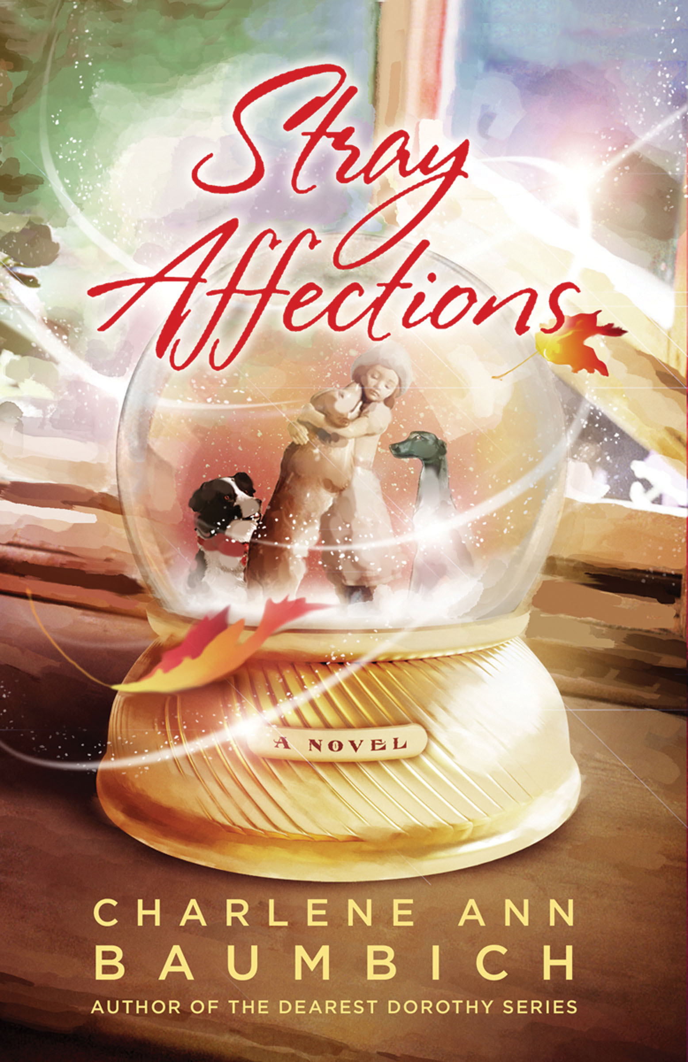Stray Affections is an original trade paperback by Charlene Ann Baumbich, the popular bestselling author of the Dearest Dorothy books.
Heaven to Betsy/Betsy in Spite of Herself 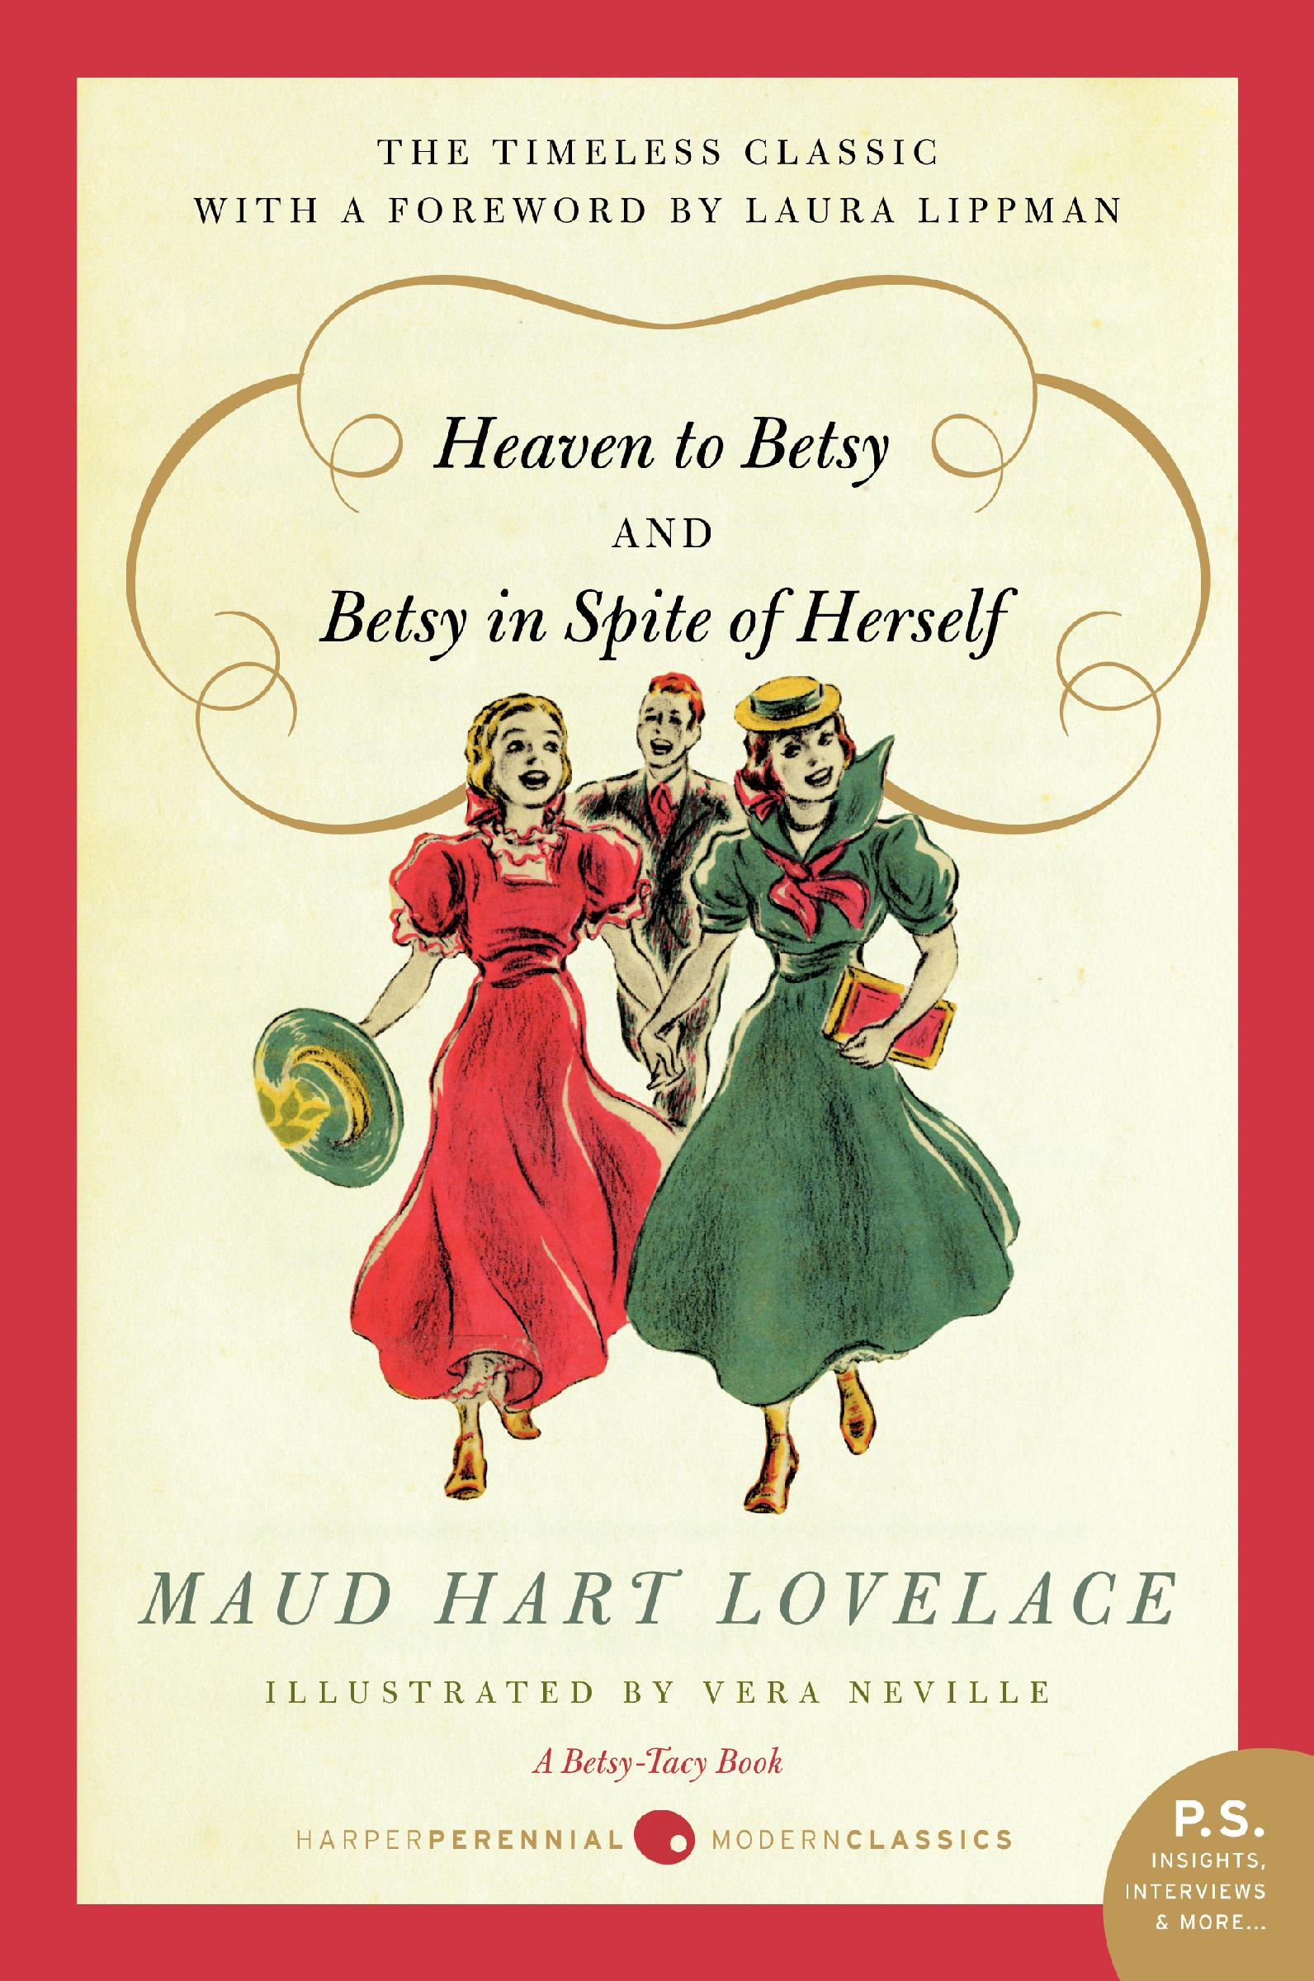Betsy was a Junior/Betsy and Joe 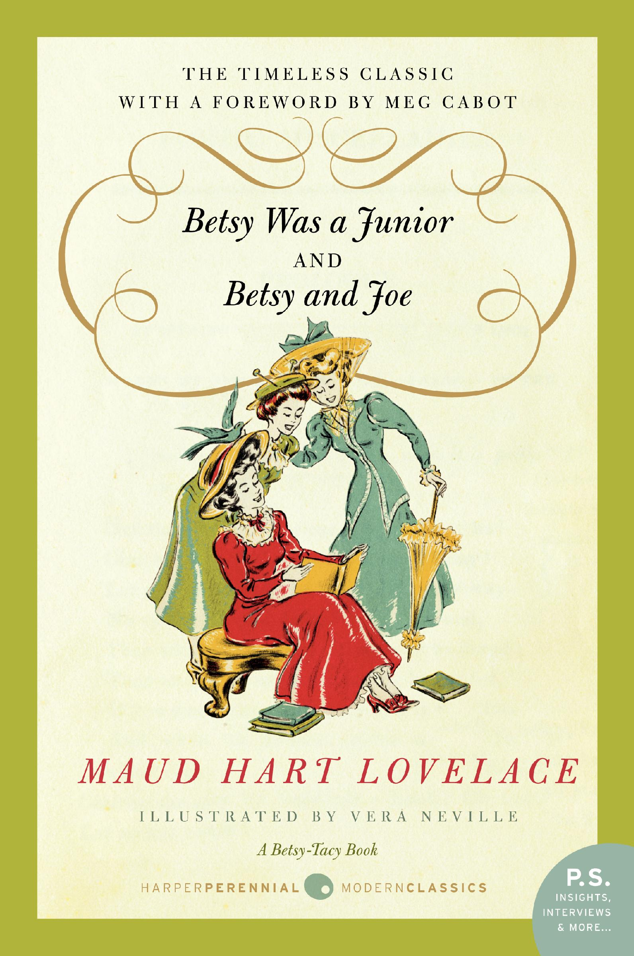 Betsy and the Great World/Betsy’s Wedding 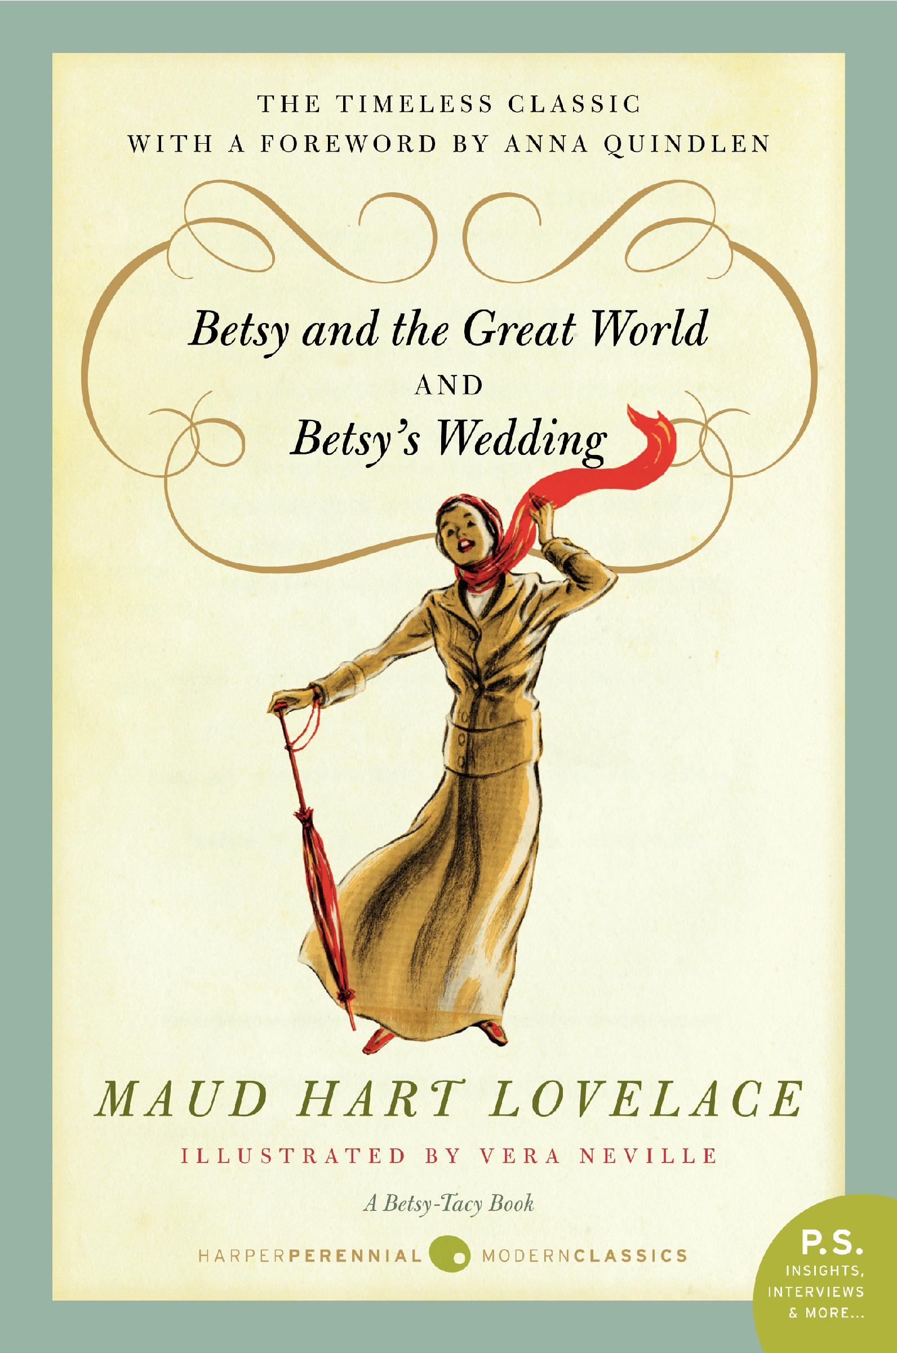 by Maud Hart Lovelace $14.99 each
Staff Picks Bob: Fleet of Worlds by Larry Niven and Edward M. Lerner $7.99 

Linda:
The Girl with the Dragon Tattoo by Steig Larsson $7.99 (also available in trade paperback for $14.95)
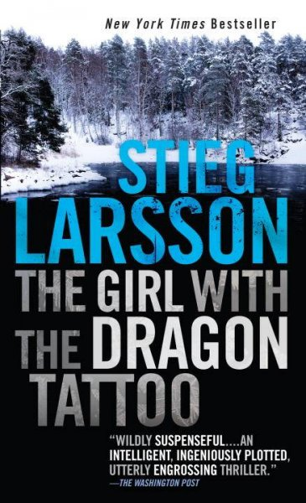 Linda says: This Swedish mystery is the first of a trilogy, and I can hardly wait to read the second, The Girl Who Played with Fire. You'll have a hard time turning out the lights and not reading straight through the night.
Missing Mark by Julie Kramer $25 (a Midwest Connections Pick!) Linda says: This is the sequel to Stalking Susan; and if you love mysteries filled with Minnesota tidbits, you'll really enjoy this book.
The Bufflehead Sisters by Patricia J. Delois $15
Jody:
The Artist’s Way Every Day: A Year of Creative Living by Julia Cameron $14.95 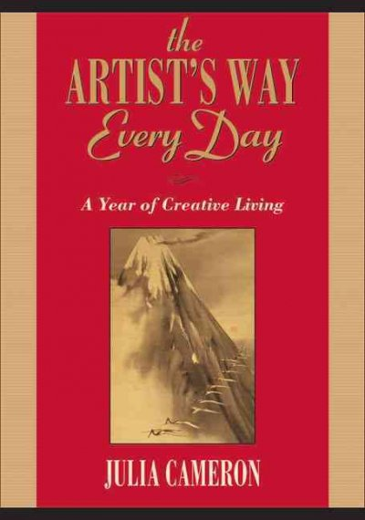

Gail:
Daughters of the Desert: Stories Of Remarkable Women From Christian, Jewish, And Muslim Traditions by Claire Murphy $14.99
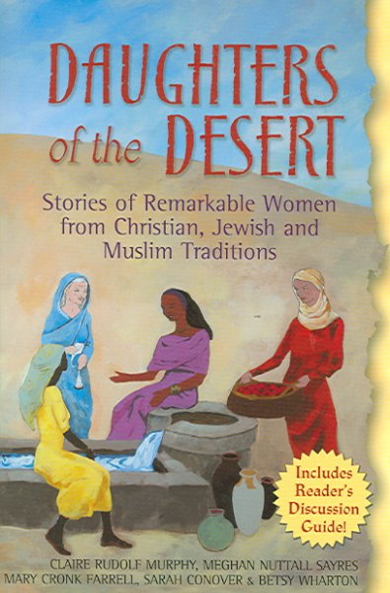

Jennie:

(Jennie is on vacation ☺)
Sally:
Day After Night by Anita Diamant $27
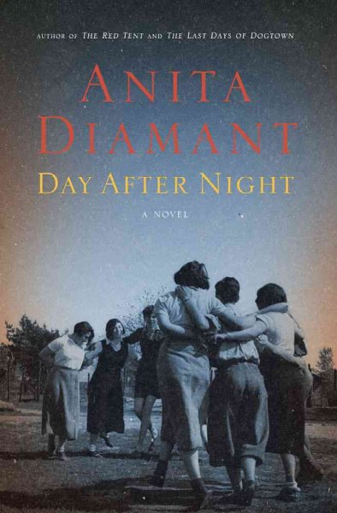 Sally says: Diamant's latest book is a novel based on an historical event: the escape in 1945 of over 200 Jewish internees from Atlit, a refugee camp run by the British after World War II. The story follows four young women, all survivors of the Holocaust, each with a different story. Recently, a number of fine novels about World War II have been published. You'll want to add this one to your list of books to read.

Cindie:
Wild Things by Dave Eggers $19.95
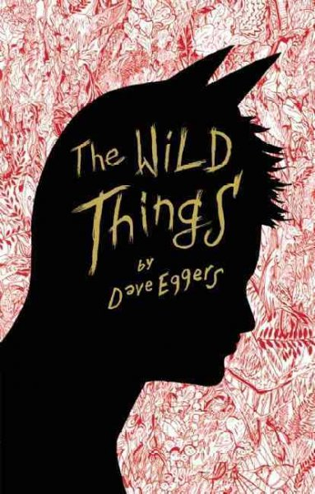

Jennifer:
The Year of the Flood by Margaret Atwood on audio $45 (hardcover is $26.95)
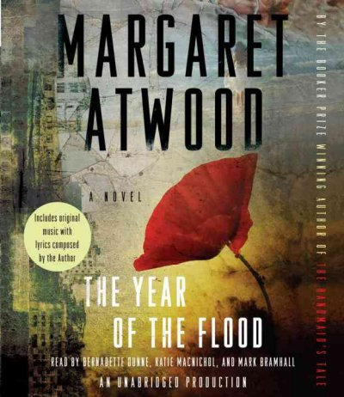
Breakfast with the Buddha by Roland Merullo

Youth Yak
Young Adult Pick by Sally:
The Sorceress by Michael Scott on audio $50 (hardcover is $17.99)
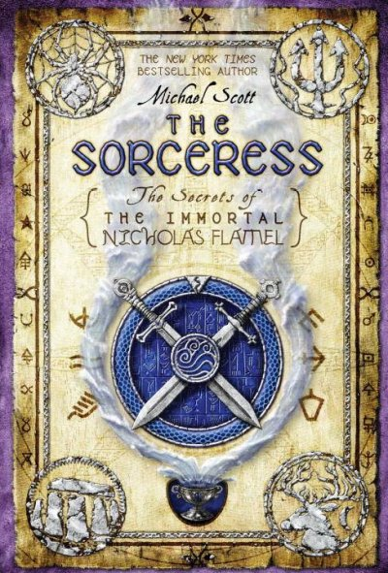
Sally says: I'm listening to the audio of this young adult book, the third in the Story of the Immortal Nicholas Flamel series. We've been suggesting this series to young people who loved the Harry Potter series. Like that series, this one features sympathetic young protagonists, an epic fight of good versus evil, and the use of magic. All the books in the series are available at Beagle Books, and we can order the audio book.
Front and Center by Catherine Gilbert Murdock $16
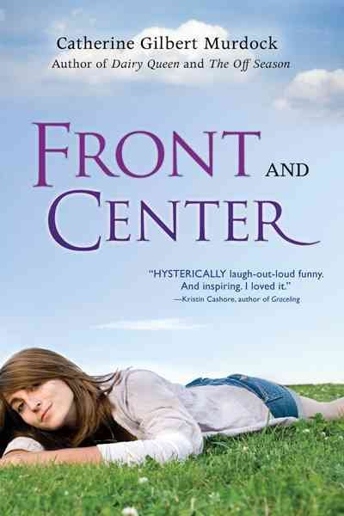
In this hilarious and moving conclusion to the Dairy Queen trilogy, D.J. Schwenk returns to her small-town high school – only to find herself the focus of far too much attention. From an old friend now hot for romance, to college recruiters and rabid local hoops fans, to Brian Nelson . . . How will shy, quiet D.J. handle things now that she’s front and center?
*Get a signed copy at Beagle Books!

Book Group Picks
Beagle Books Mens Book Group
Tuesday, October 20th at 8AM:
Breakfast with Buddha by Roland Merullo $13.95
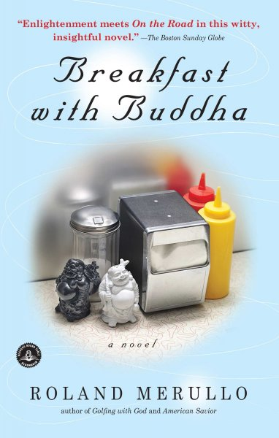

Beagle Books Womens Book Group
Saturday, October 10th at 10AM:
A Thousand Splendid Suns by Khaled Hosseini $16
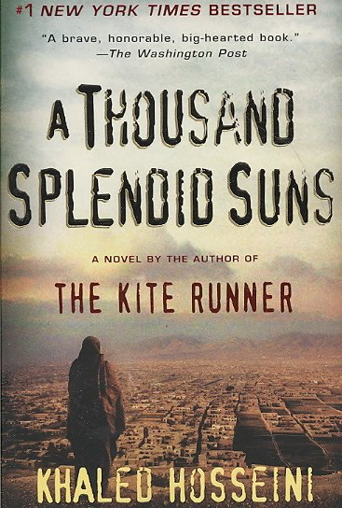

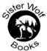 Newsletter Coupon 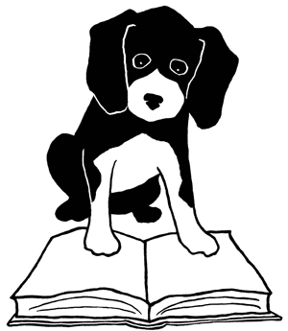
20% off any one book.

